**Flow of project:**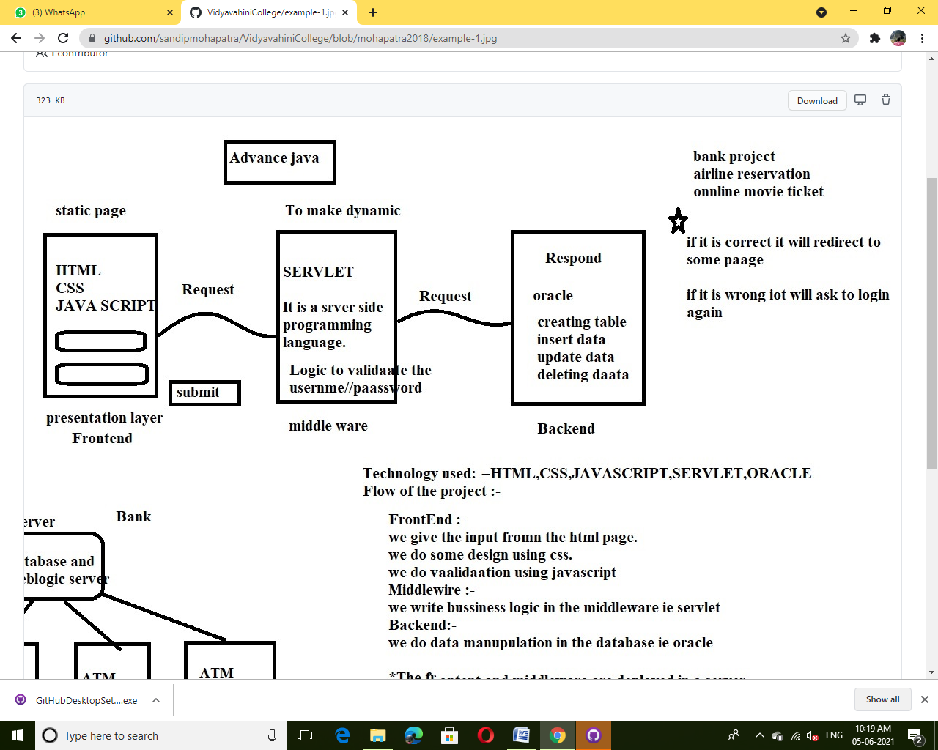

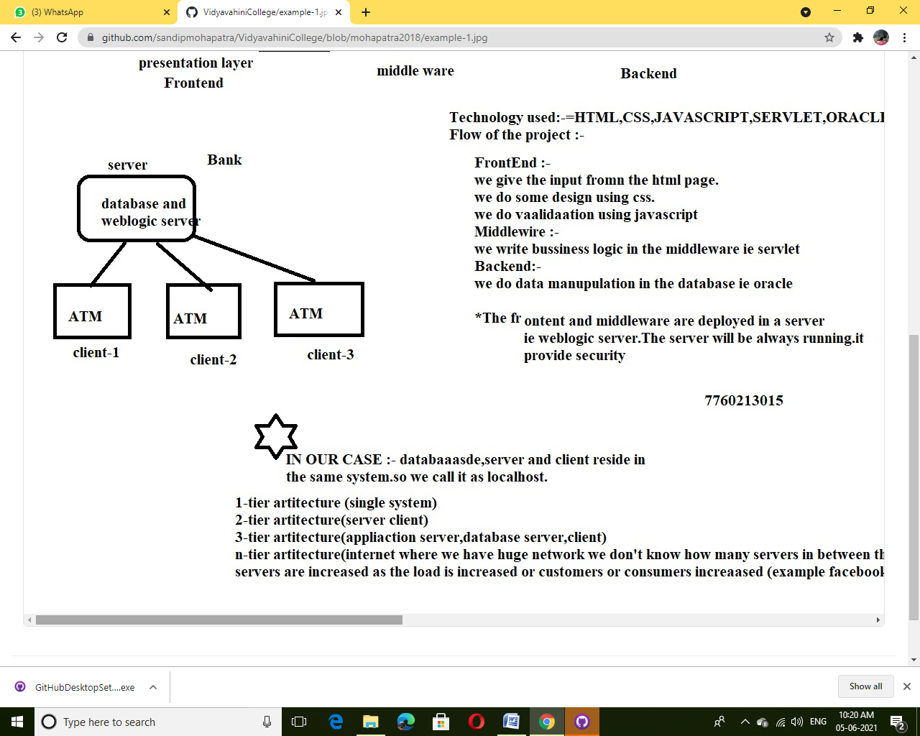

**Tier Architecture:**

## Types of DBMS Architecture

There are mainly three types of DBMS architecture:

* One Tier Architecture (Single Tier Architecture)
* Two Tier Architecture
* Three Tier Architecture
* N Tier Architecture

## 1-Tier Architecture

**1 Tier Architecture** in DBMS is the simplest architecture of Database in which the client, server, and Database all reside on the same machine. A simple one tier architecture example would be anytime you install a Database in your system and access it to practice SQL queries. But such architecture is rarely used in production.

[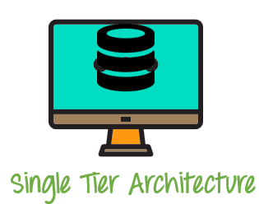](https://www.guru99.com/images/1/091318_0745_DBMSArchite1.png)

**2-Tier Architecture**

A **2 Tier Architecture** in DBMS is a Database architecture where the presentation layer runs on a client (PC, Mobile, Tablet, etc.), and data is stored on a server called the second tier. Two tier architecture provides added security to the DBMS as it is not exposed to the end-user directly. It also provides direct and faster communication.

[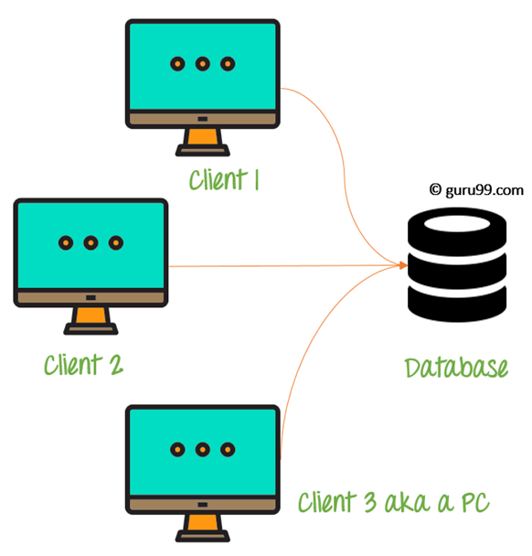](https://www.guru99.com/images/1/091318_0745_DBMSArchite2.png)

2 Tier Architecture Diagram

**3-Tier Architecture**

A **3 Tier Architecture** in DBMS is the most popular client server architecture in DBMS in which the development and maintenance of functional processes, logic, data access, data storage, and user interface is done independently as separate modules. Three Tier architecture contains a presentation layer, an application layer, and a database server.3-Tier database Architecture design is an extension of the 2-tier client-server architecture. A 3-tier architecture has the following layers:

1. Presentation layer (your PC, Tablet, Mobile, etc.)
2. Application layer (server)
3. Database Server

[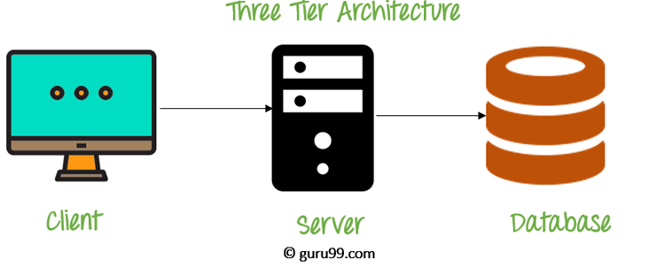](https://www.guru99.com/images/1/091318_0745_DBMSArchite3.png)

3 Tier Architecture Diagram

**N-Tier Architecture**

N-tier architecture would involve dividing an application into [three different tiers](https://msdn.microsoft.com/en-us/library/bb384398.aspx).  These would be the

1. logic tier,
2. the presentation tier, and
3. the data tier.

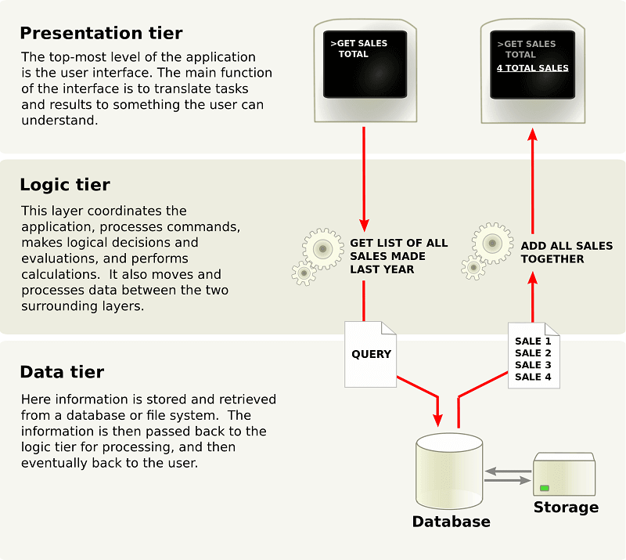

**SYSTEM REQUIREMENTS:**

1. **Oracle Software**
2. **Eclipse Software**
3. **Platform811 Software**

**Installation of Oracle Software:**

Step1: download the oracle software

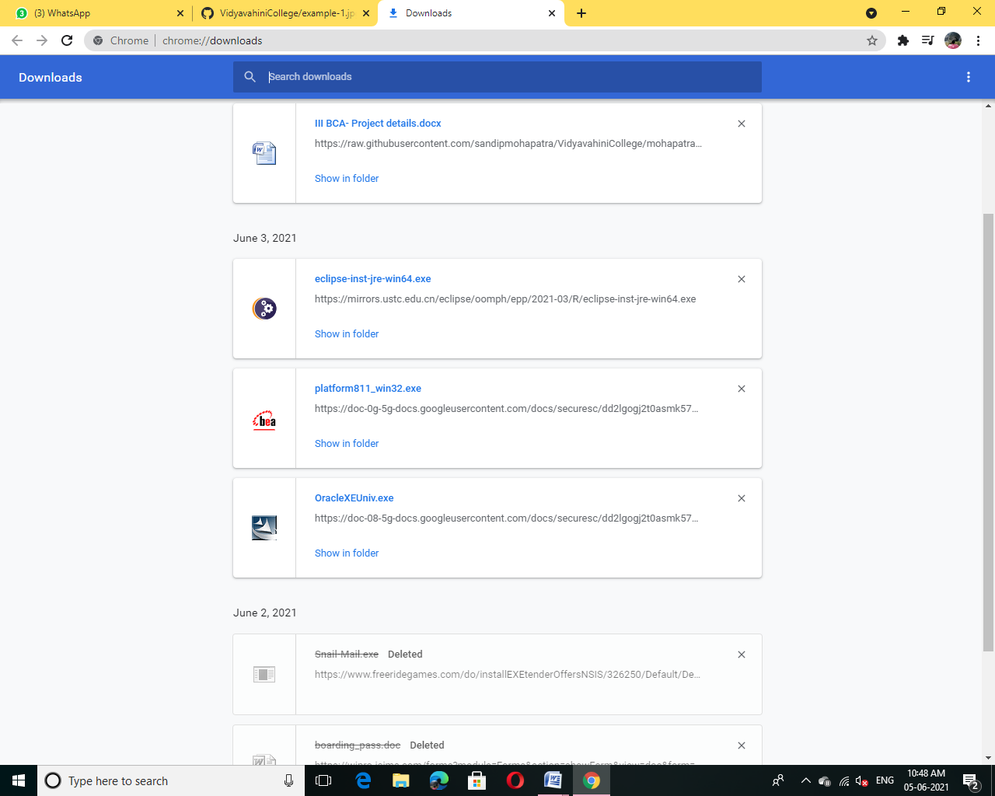

Step2: Install the oracle software

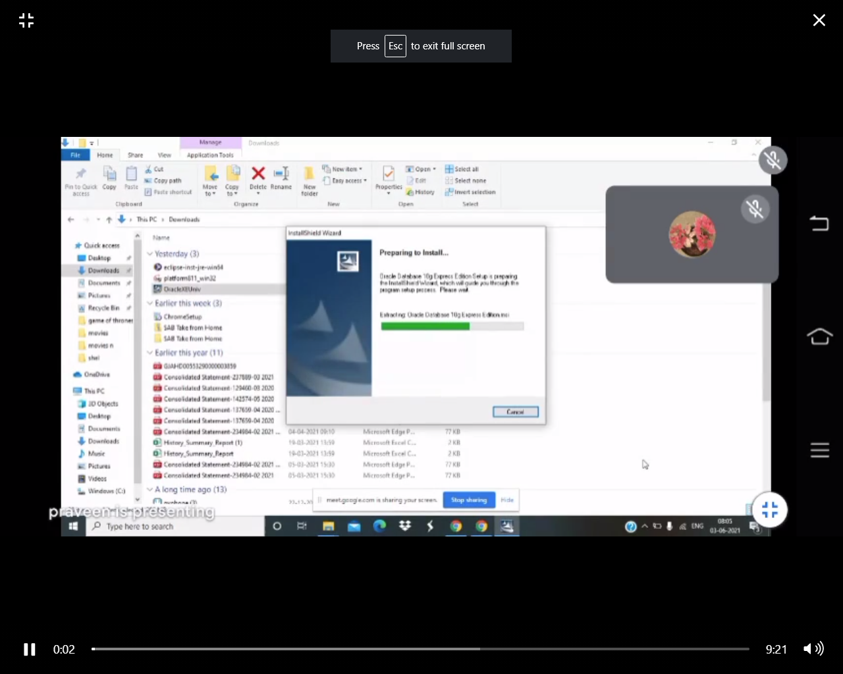

Step3:After installation select I agree then click Next

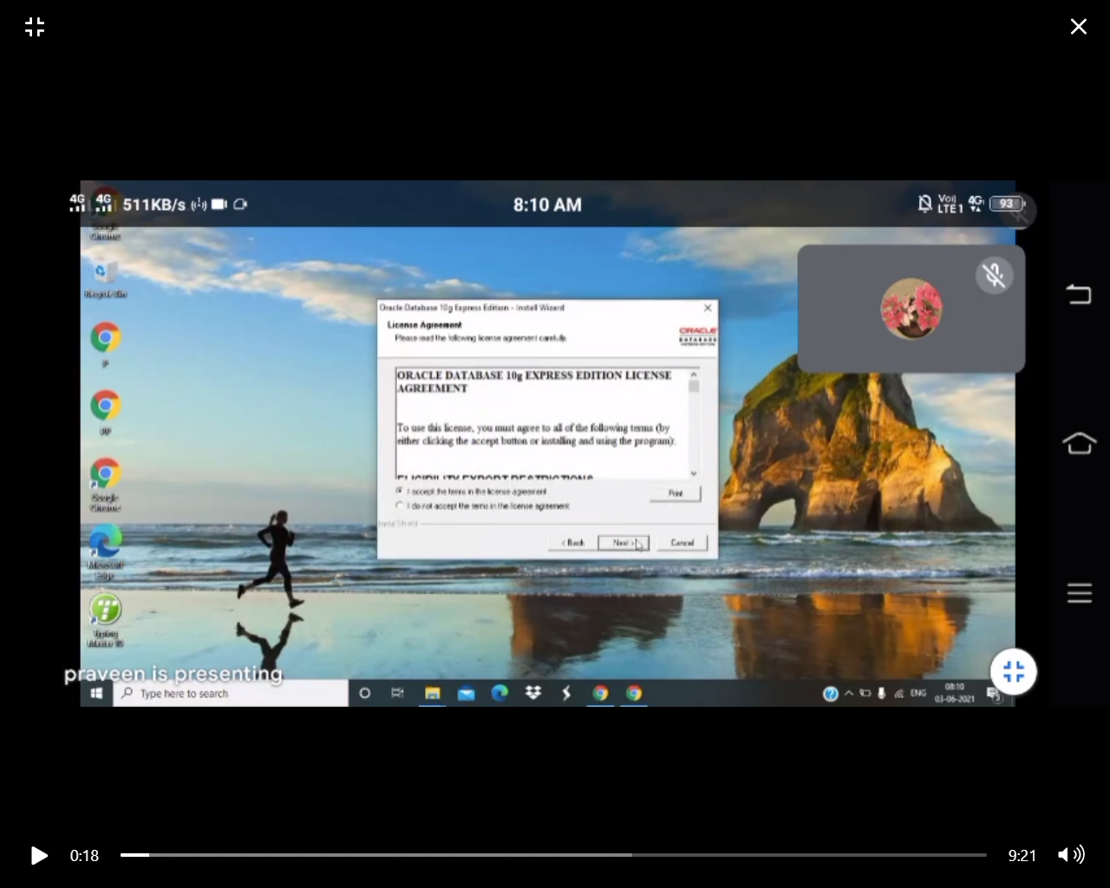

Step4:After that click Next Button again

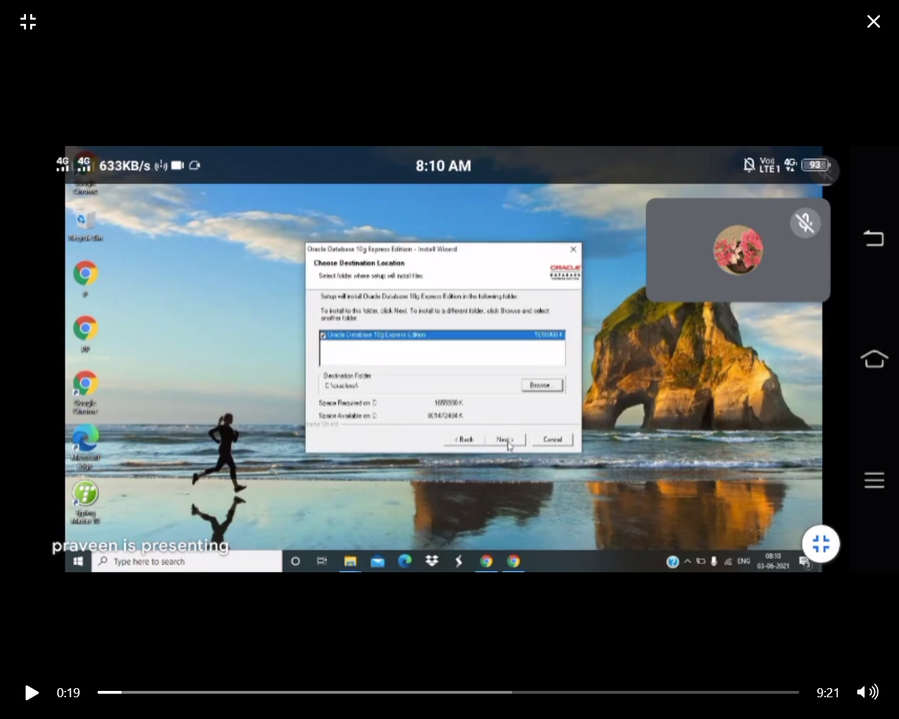

Step5:After step4 set password as 1234 and then click Next button

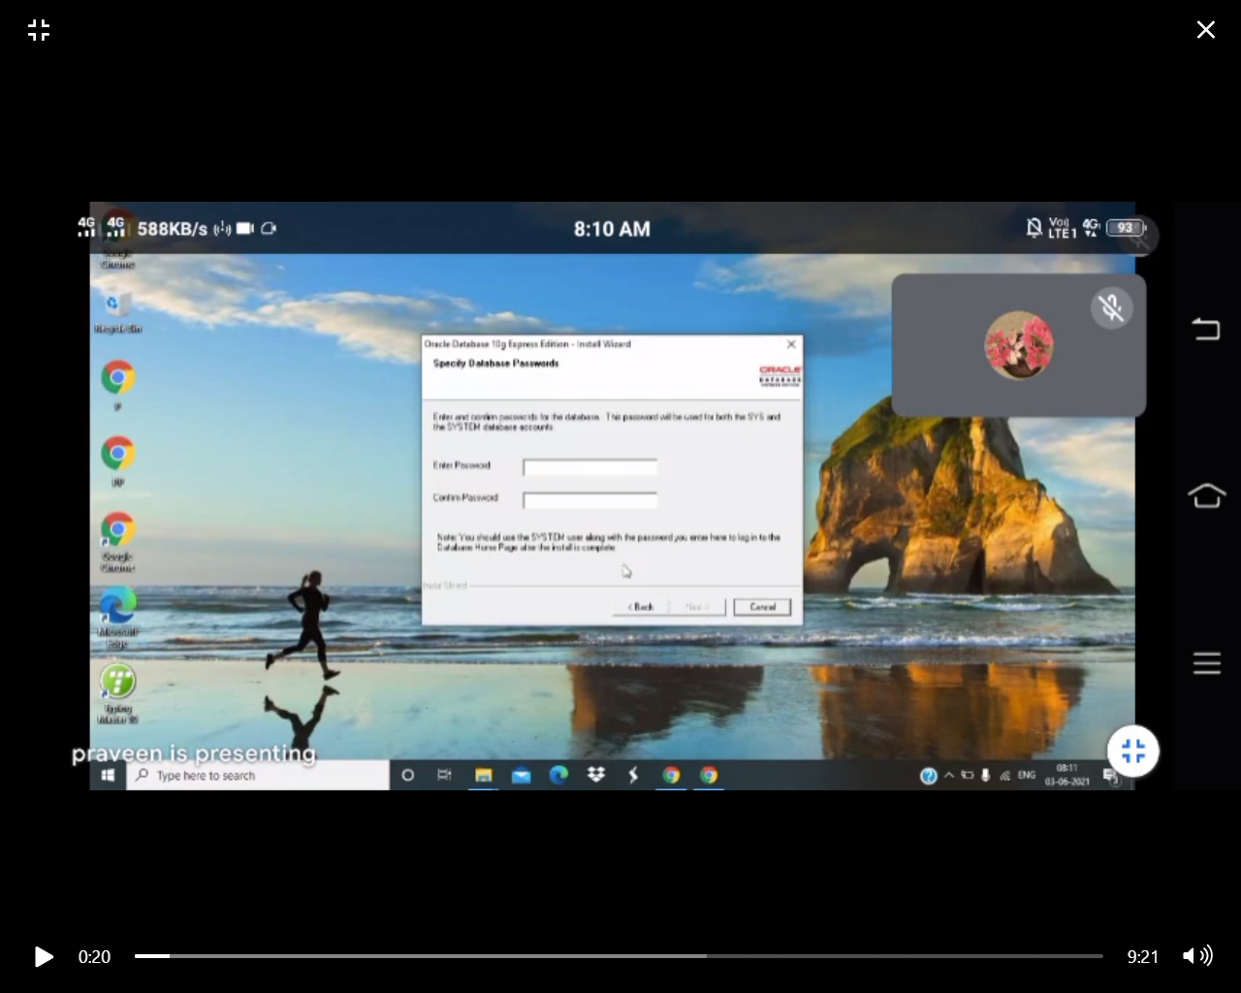

Step6:And then click Install Button

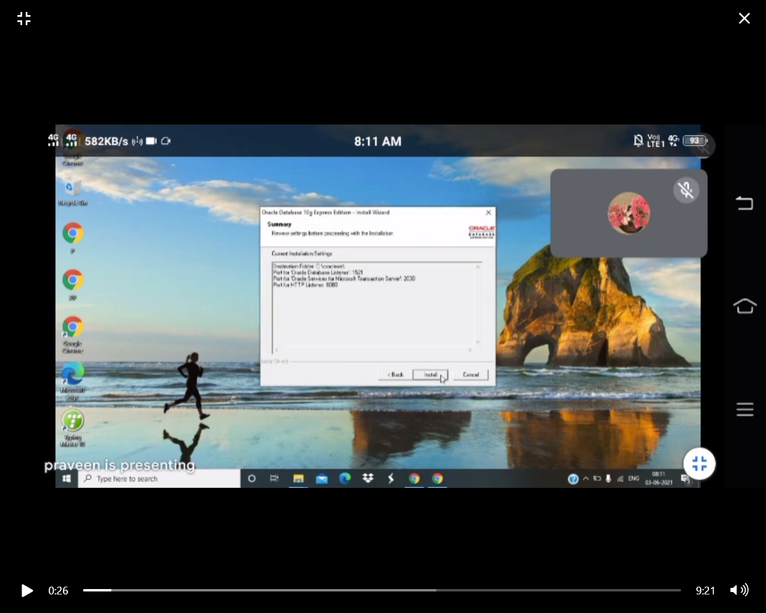

Step7:Installation process

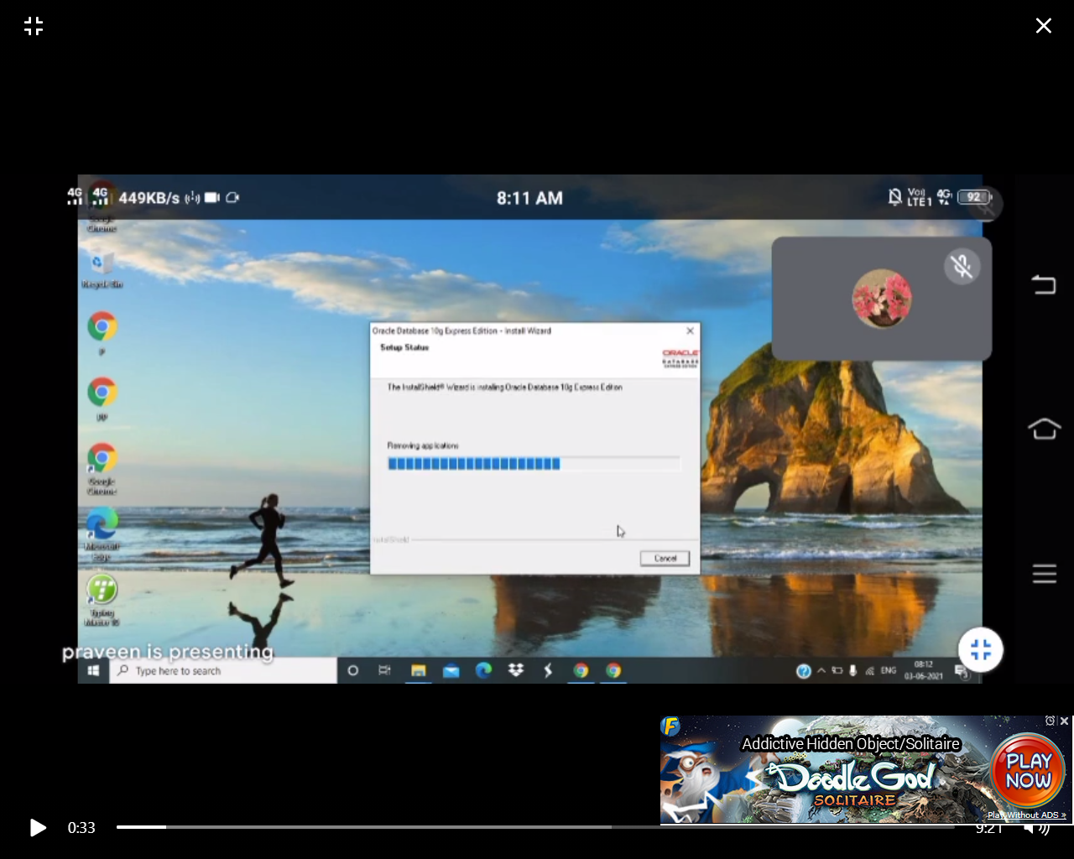

Step8:The installation is done click Finish button

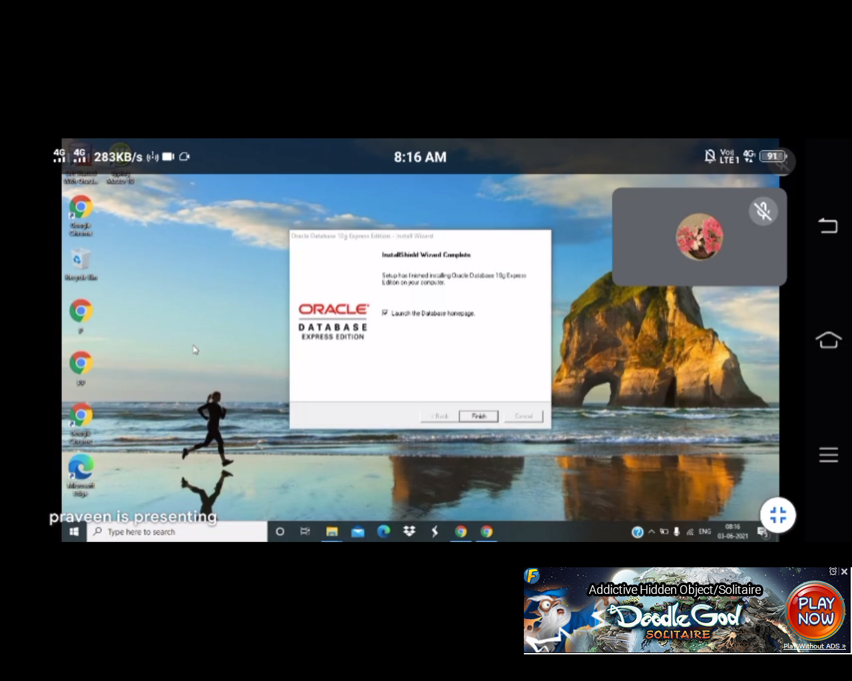

Step9:After step8 it takes to login page:

Use Username as System and password as 1234

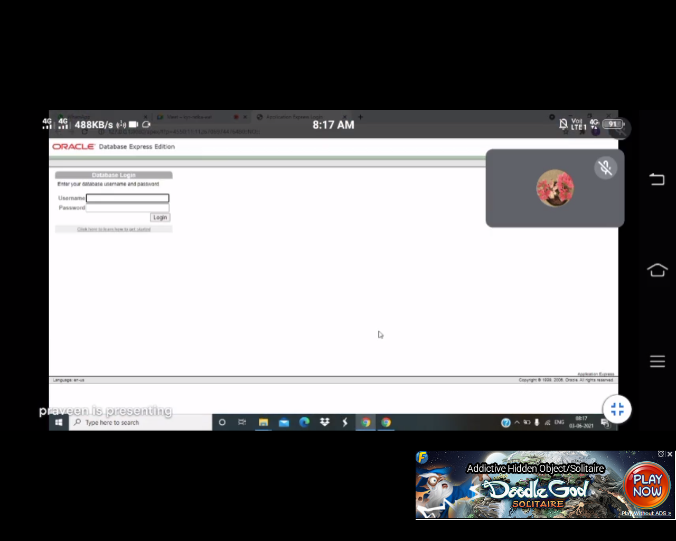

Step10:After login select SQL

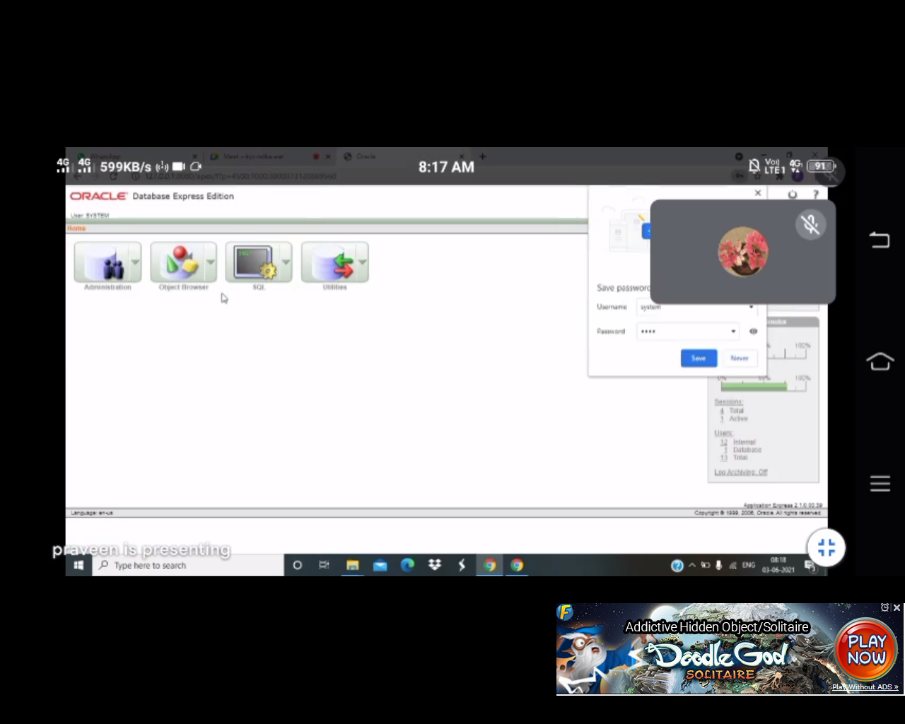

Step11:After selecting SQL click on SQL Command

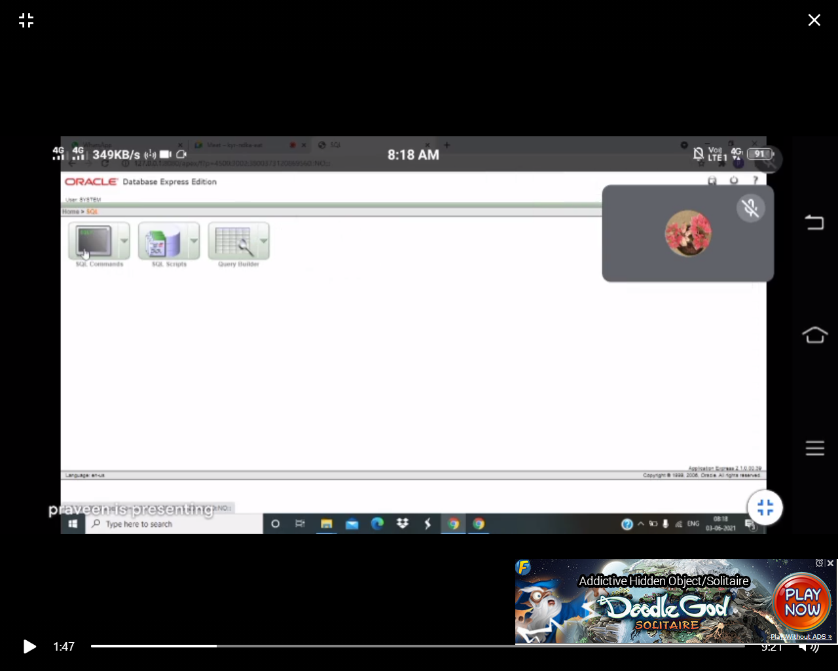

Step12:After Selecting SQL Command we can create table here

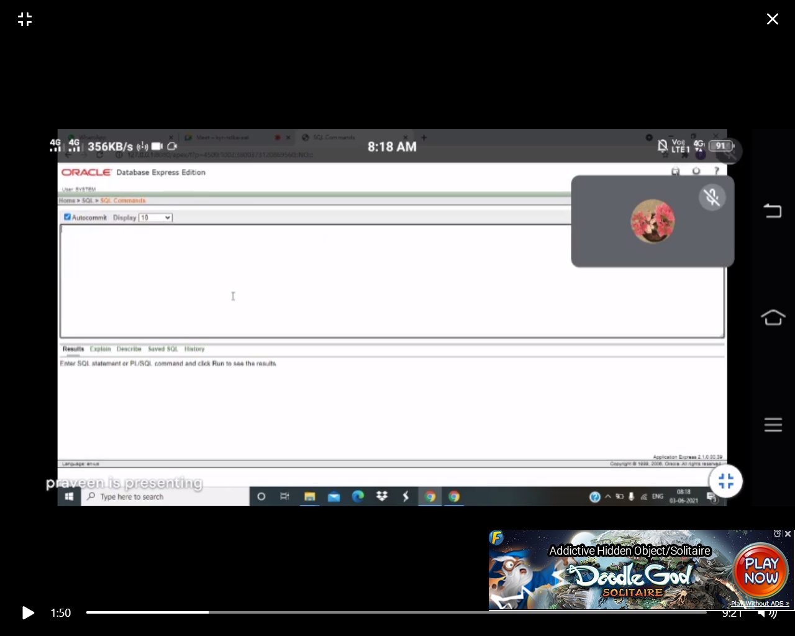

**Installation of Eclipse Software:**

Step1:Download the Software

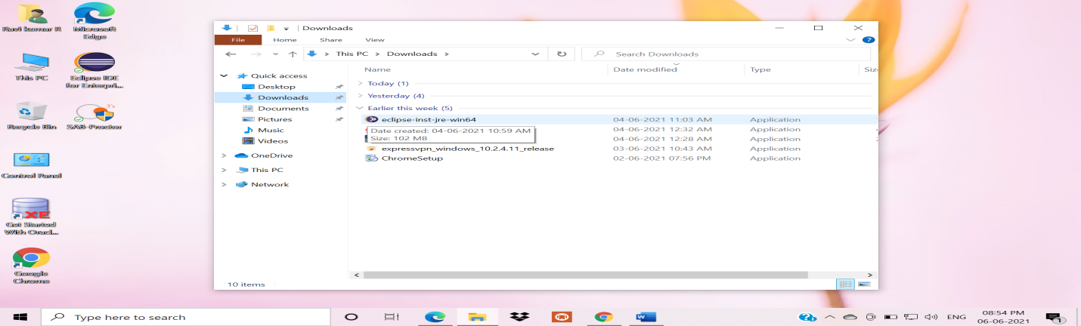

Step2:Double Click on the Software

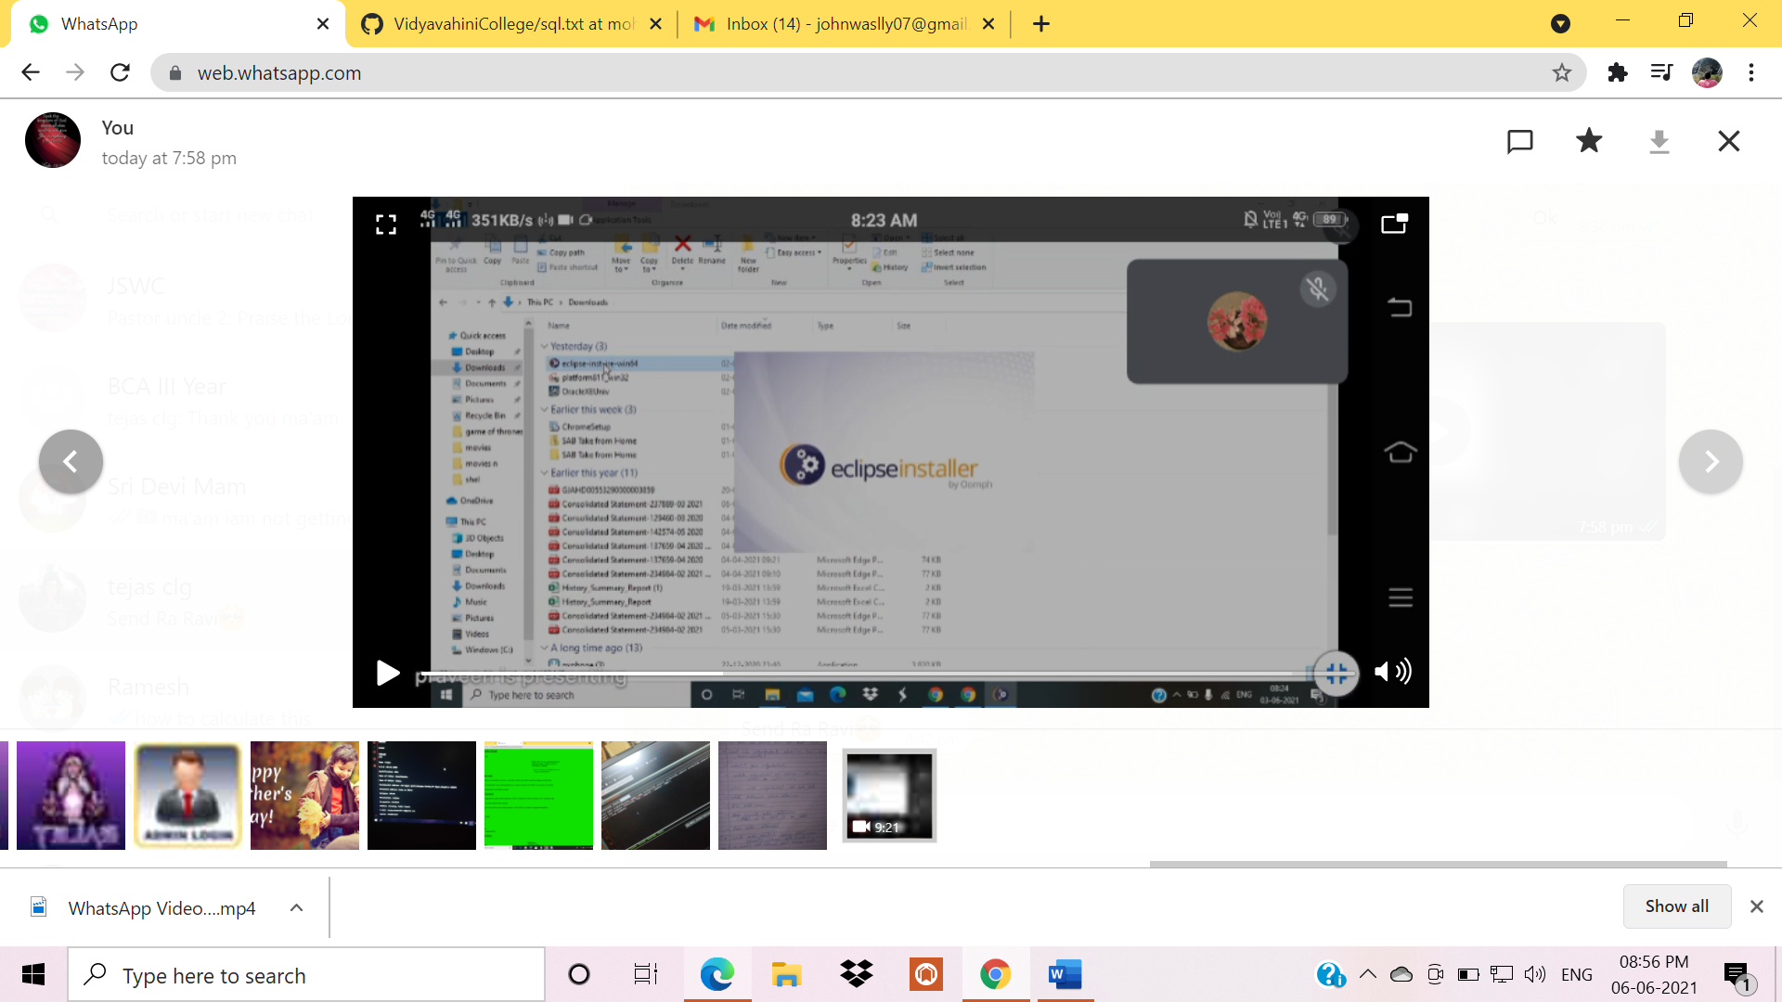

Step3:Selcet Eclipse IDE for Enterprises Java and Web Developers

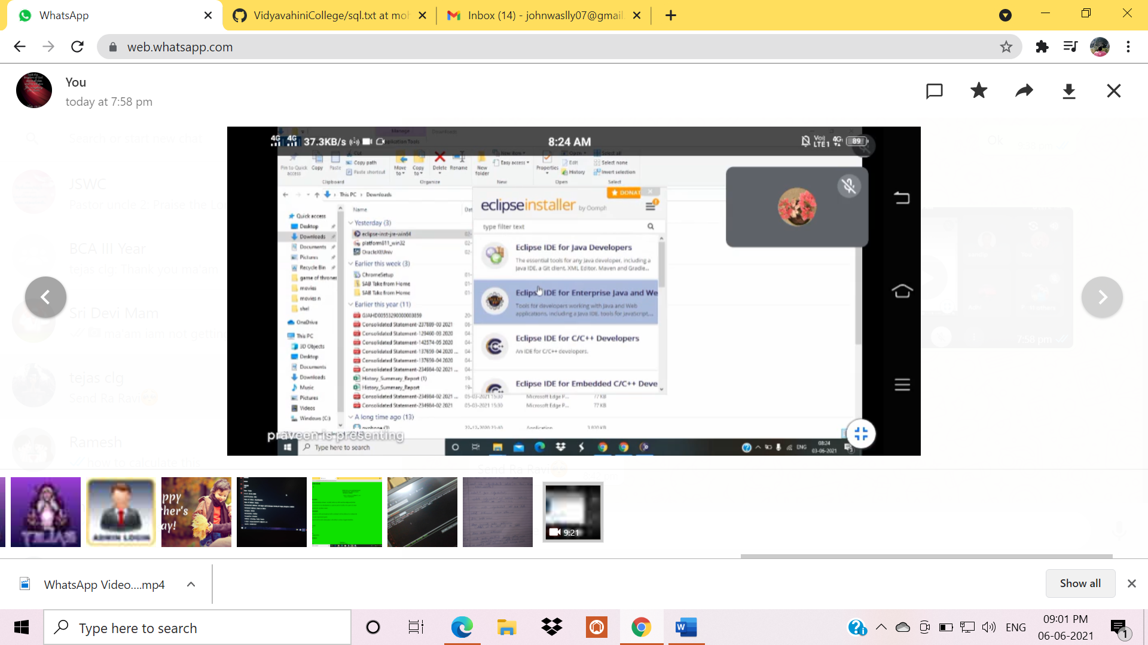

Step4:After step3 Click on Install Button

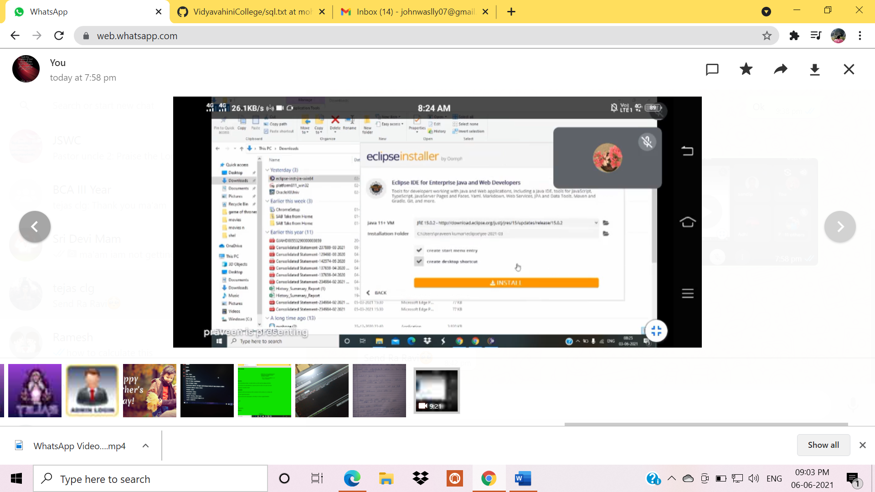

Step5:Installation Process

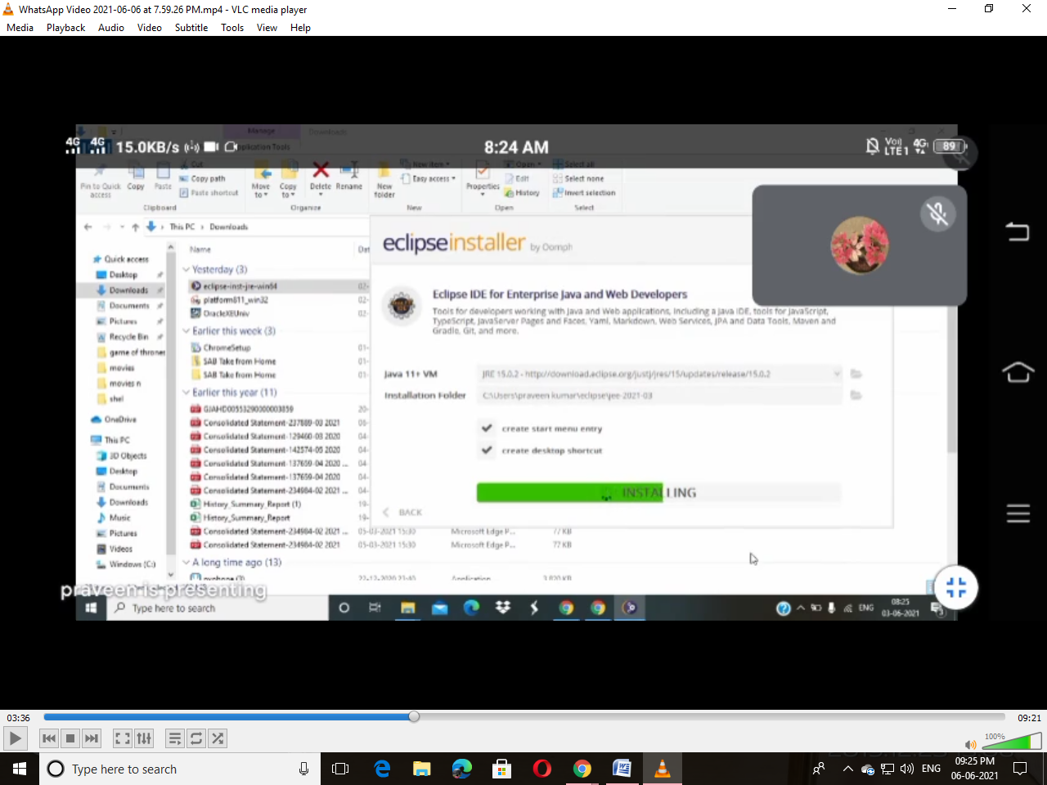

Step6:After Installation Click on Lunch Button

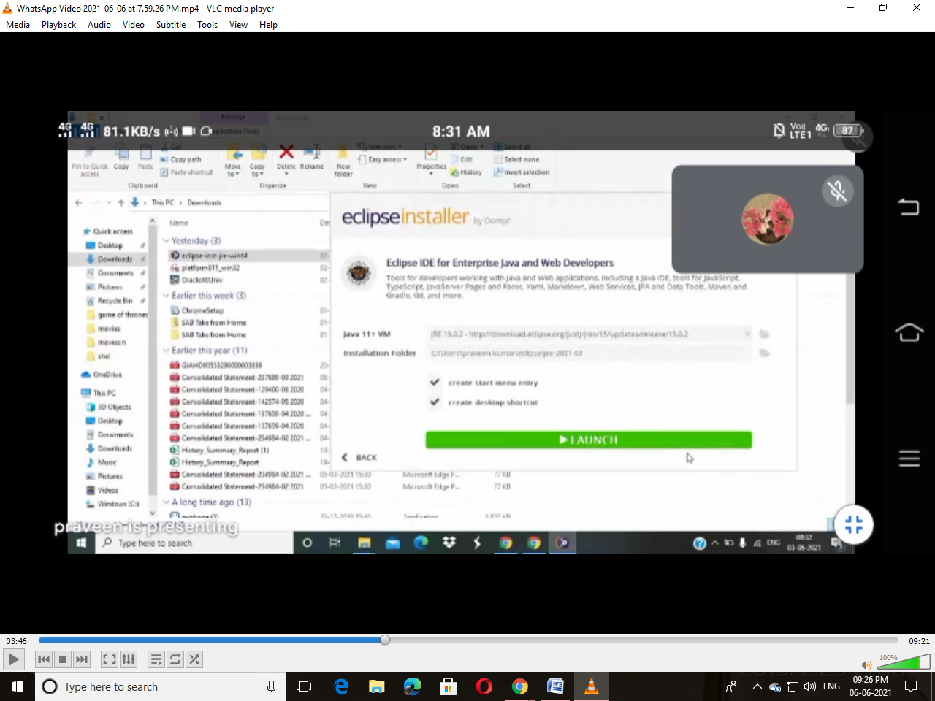

Step7:Select Directory and Click again Lunch Button

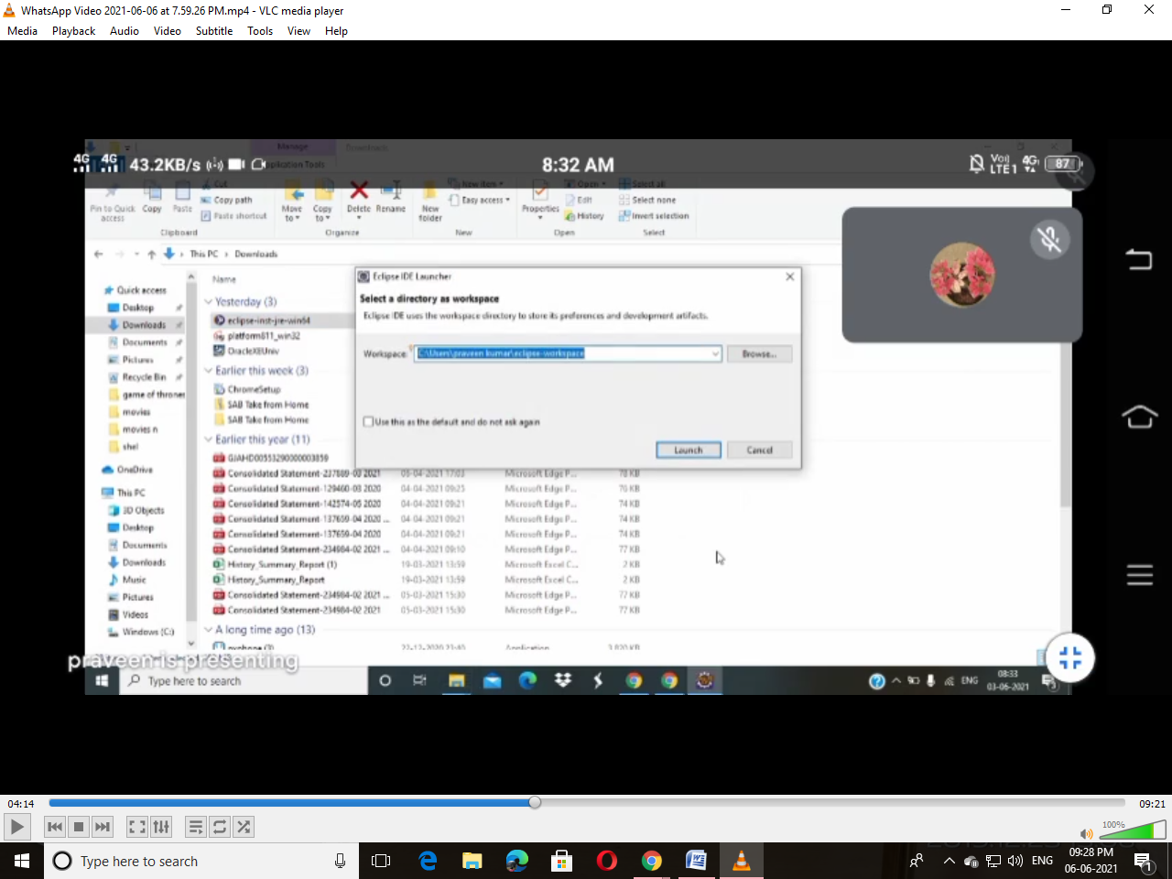

Step8:After step7 Close that Window which is show in the Picture

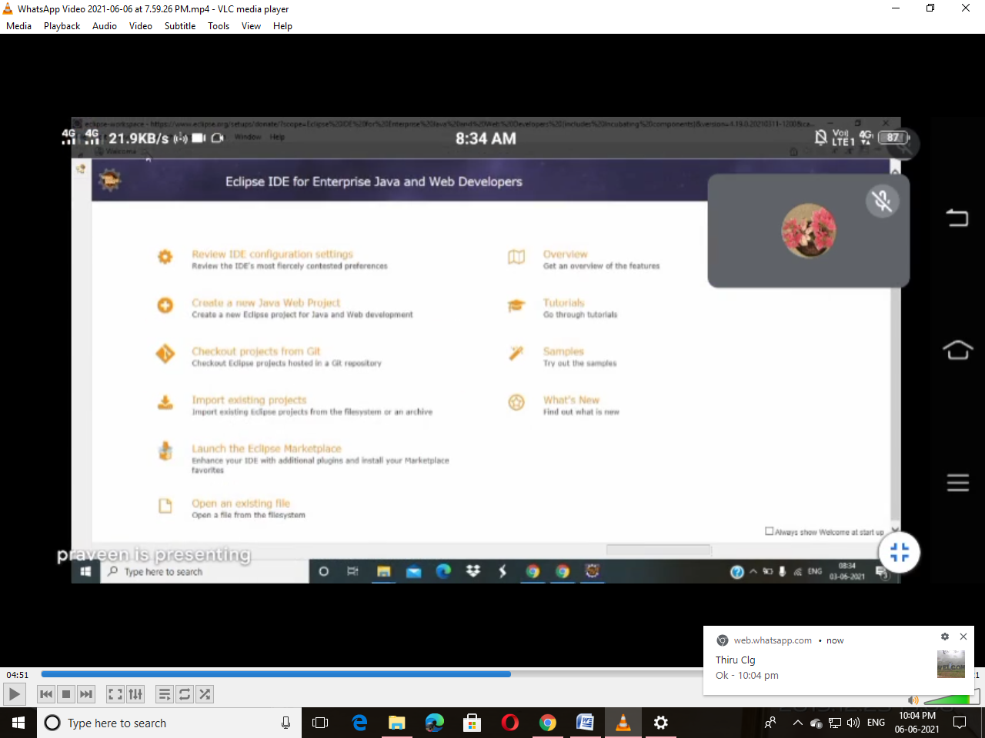

Step9:After Closing the Window it Displays like this show in below Picture

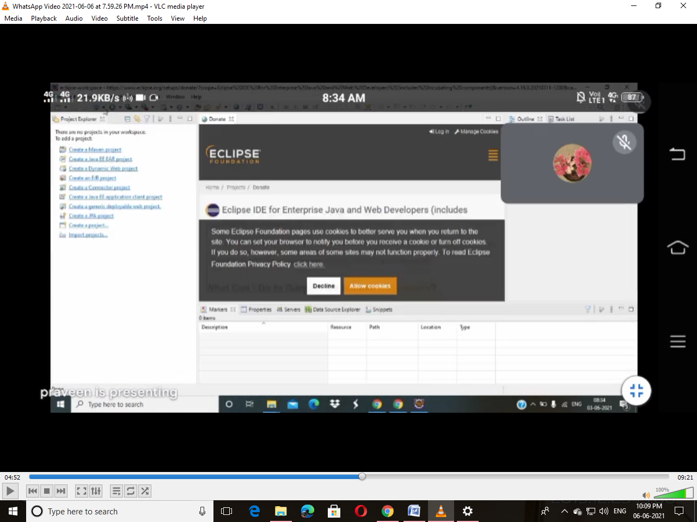

Step10:Cancal the Donate Window

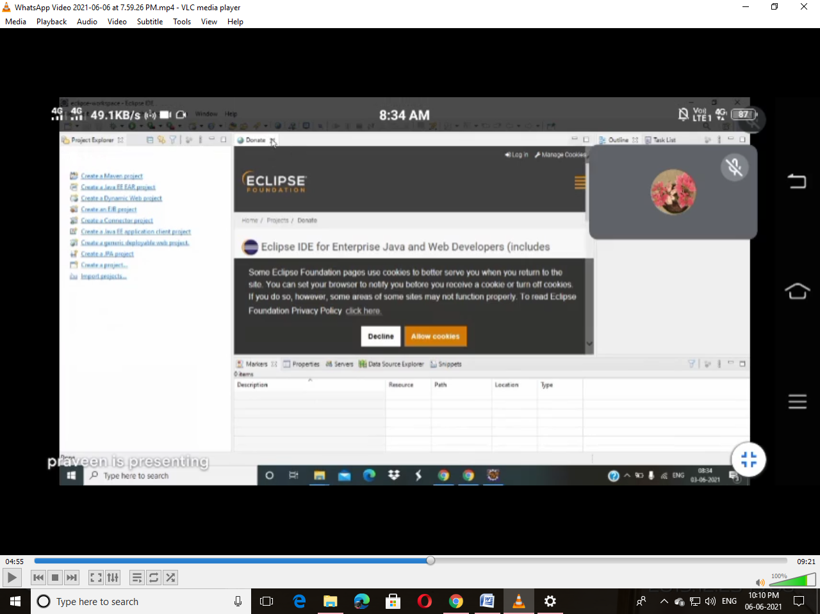

Step11:Select the Prespective which is right side of the Window

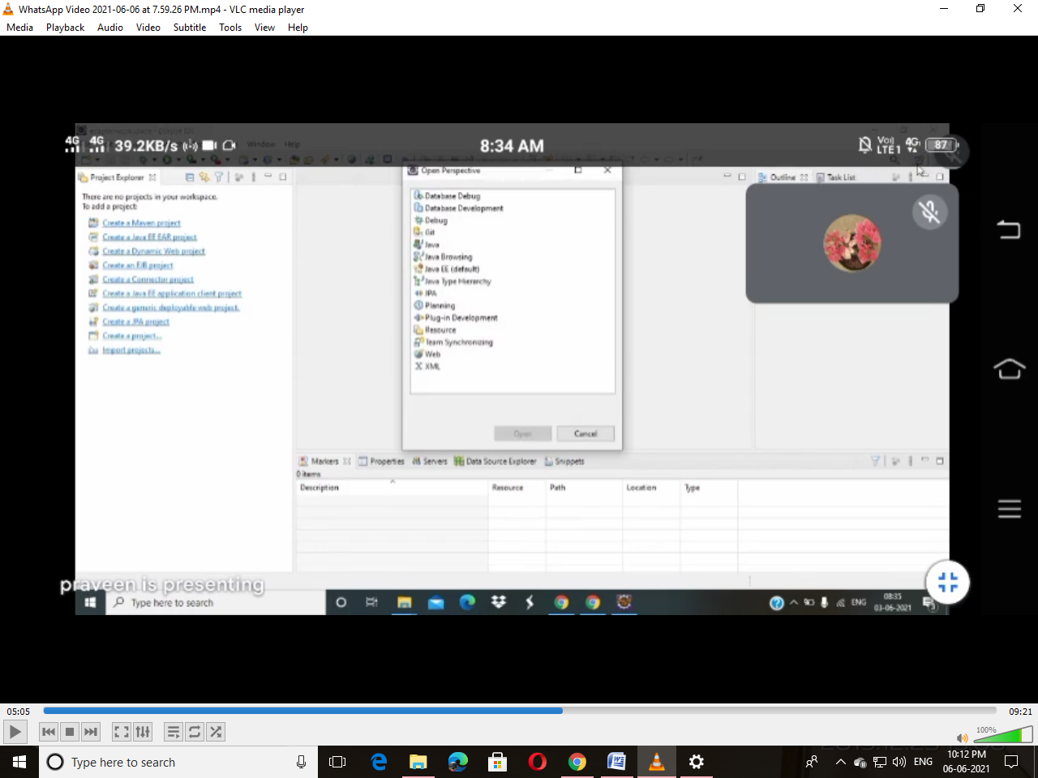

Step12:Select Java form Perspective Window

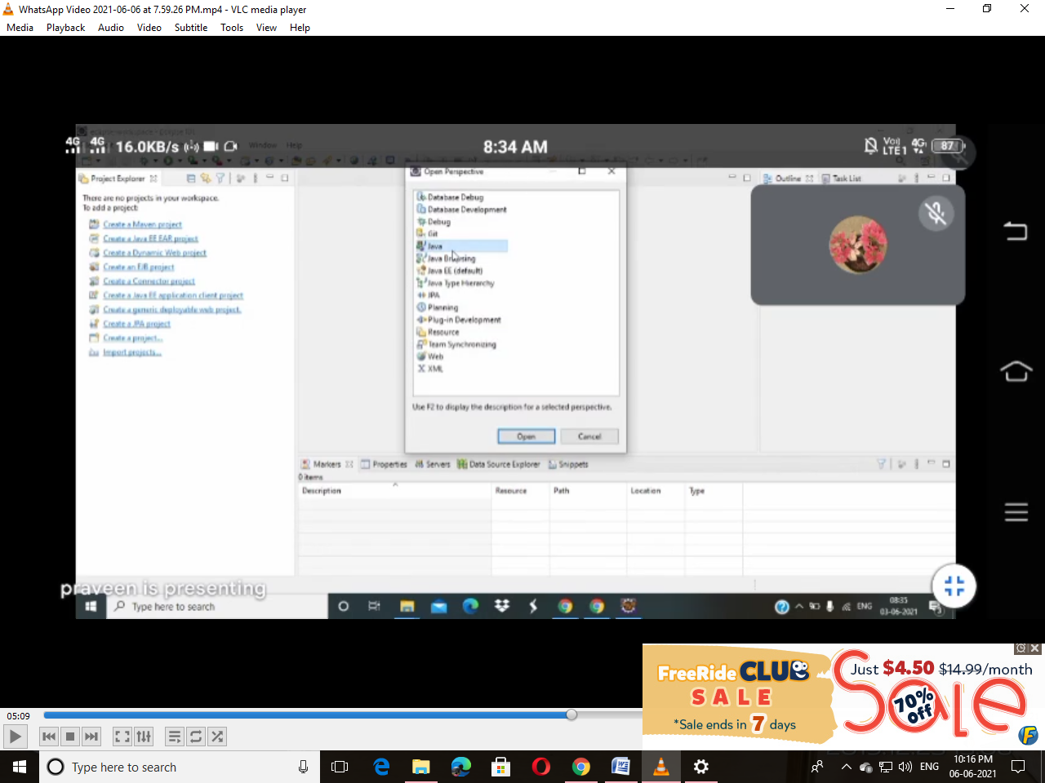

Step13:After step12 Click on File and Select New from that Select Java Project

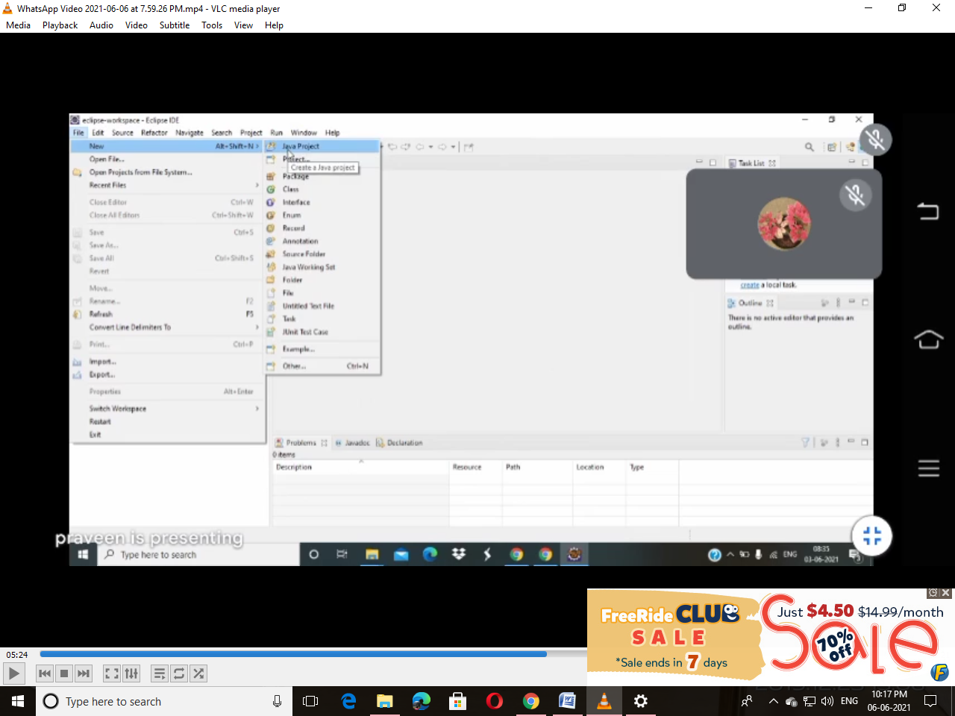

Step14:Set Name for your Project and Click Next Button

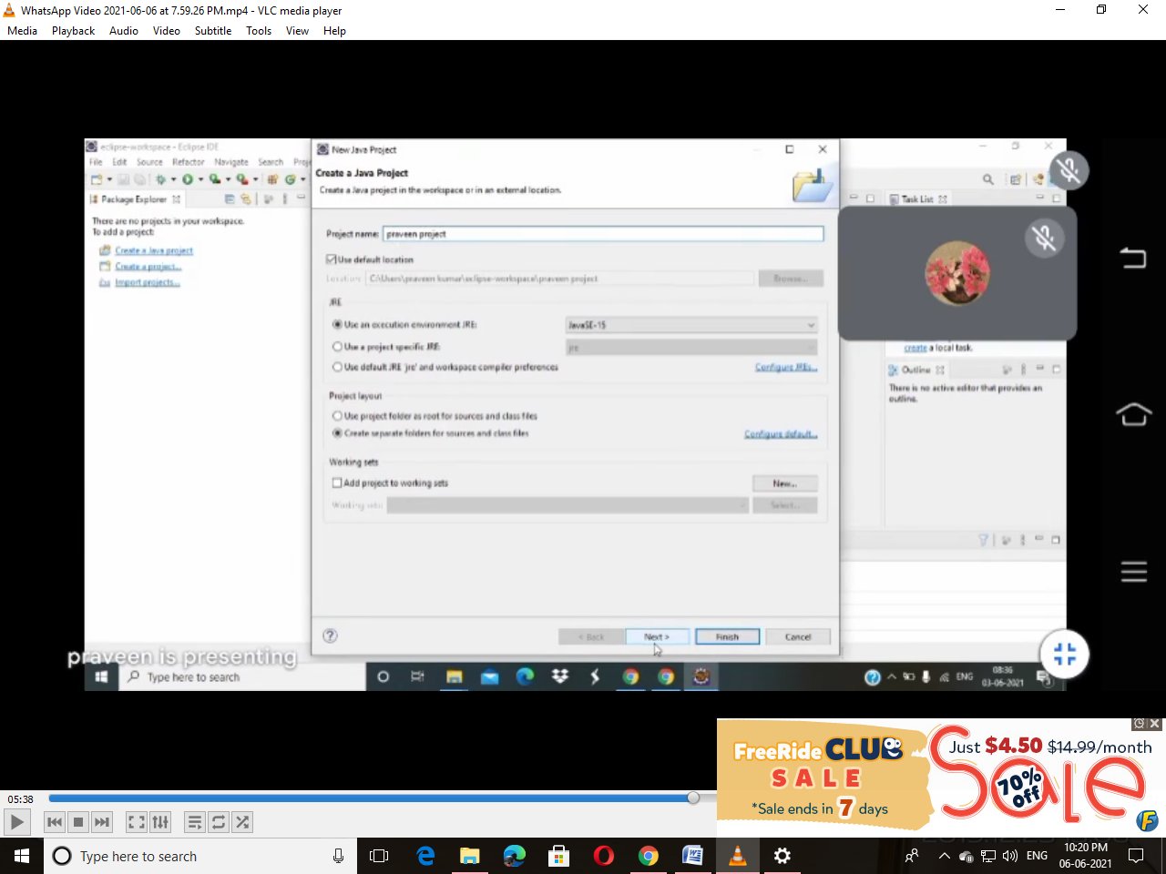

Step15:Select Finish Button

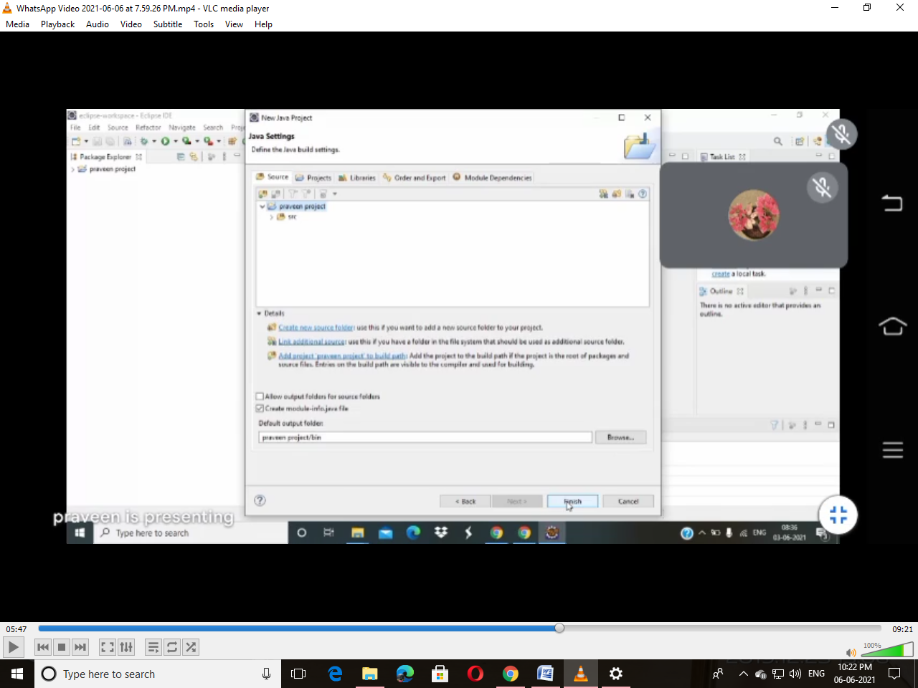

Step16:Select Don’t Create Button

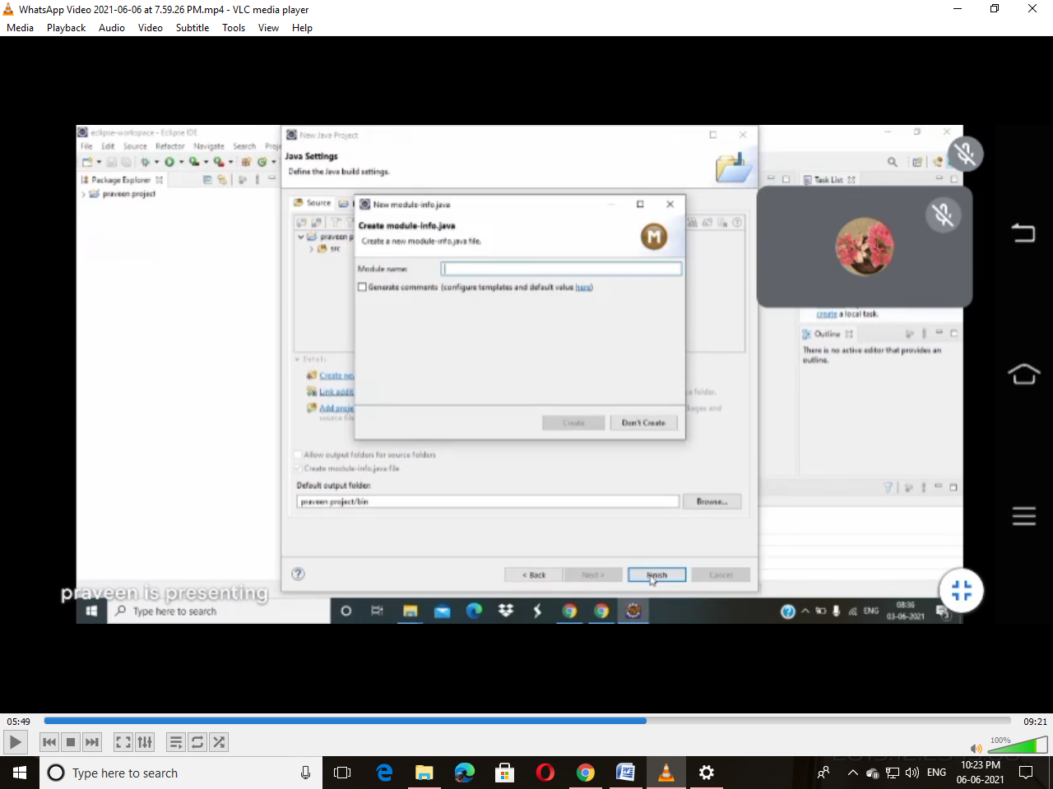

Step17:Close Task list and Outline Window

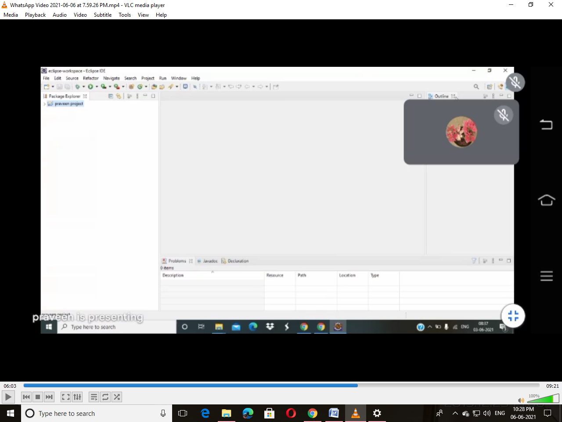

Step18: Click on Project Which is Created in your Name 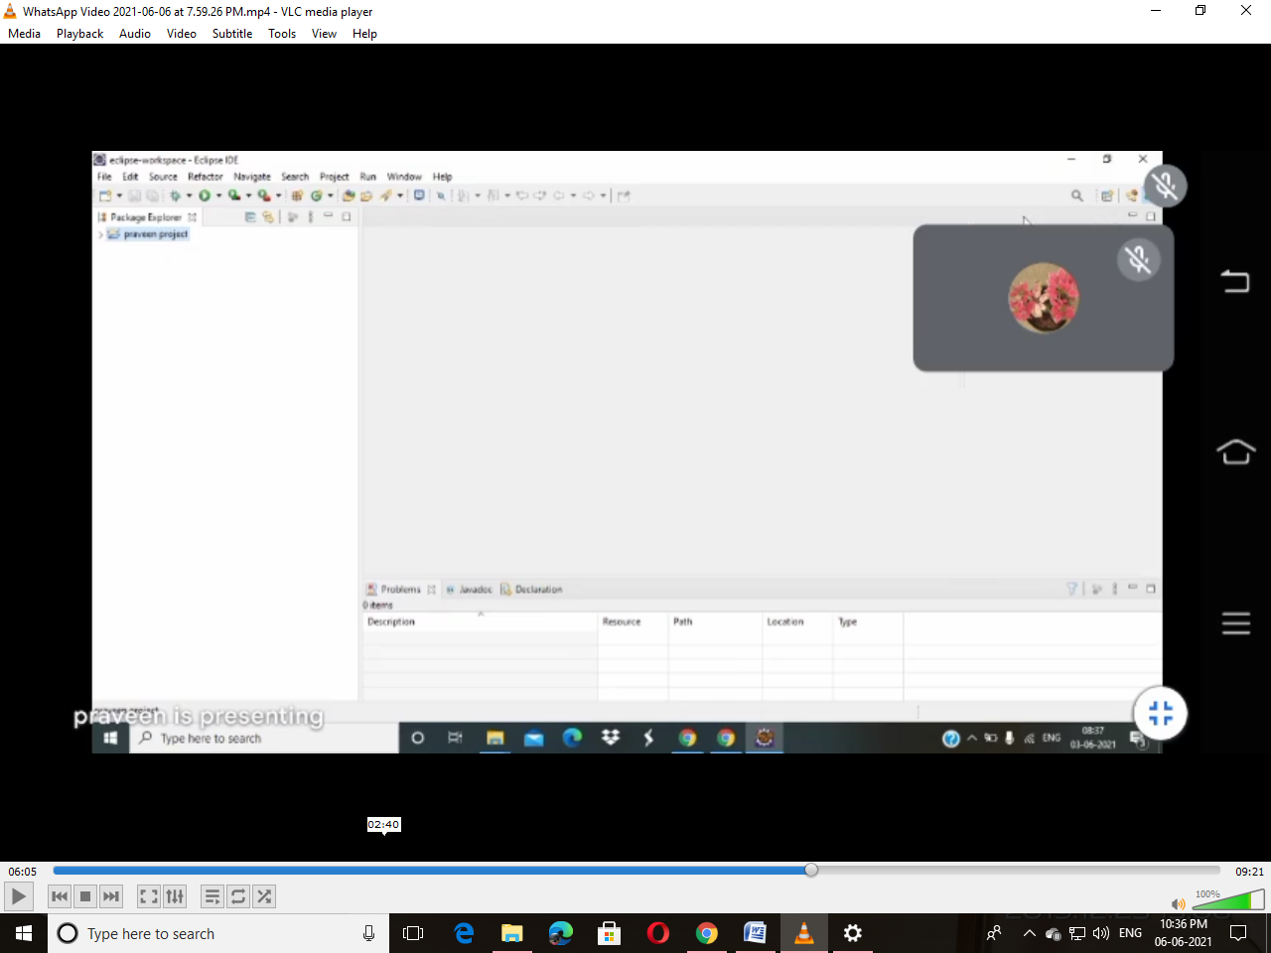

Step19:Right Click on Source (src)

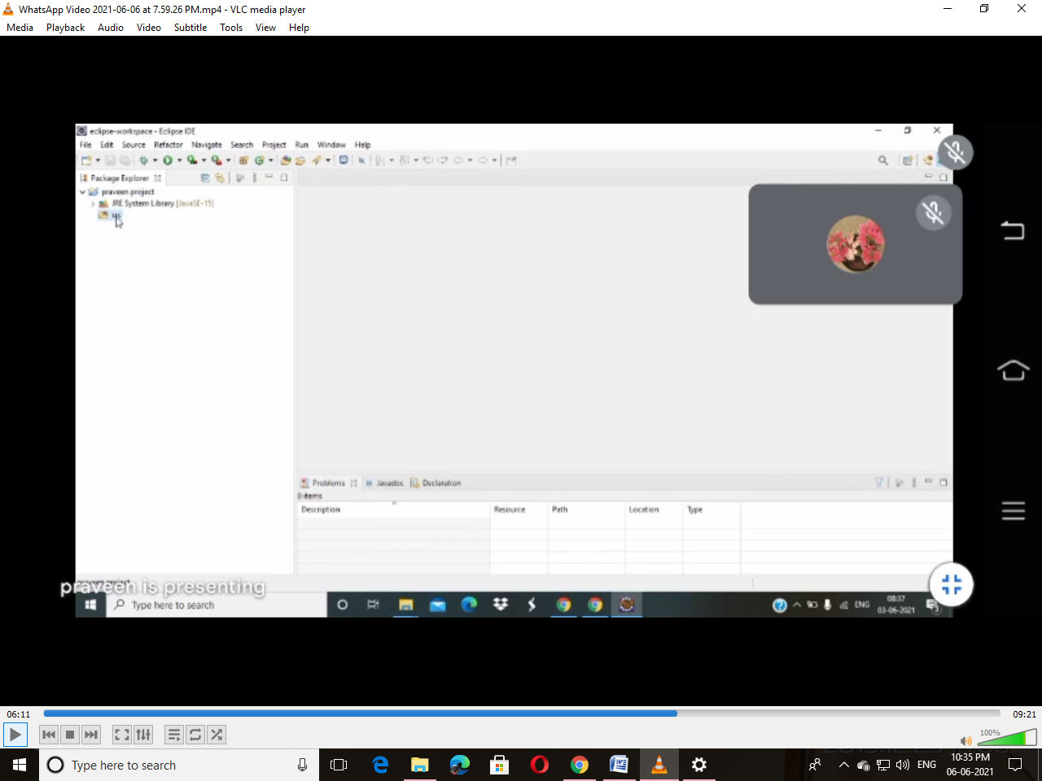

Step20:Select New in that Click on class

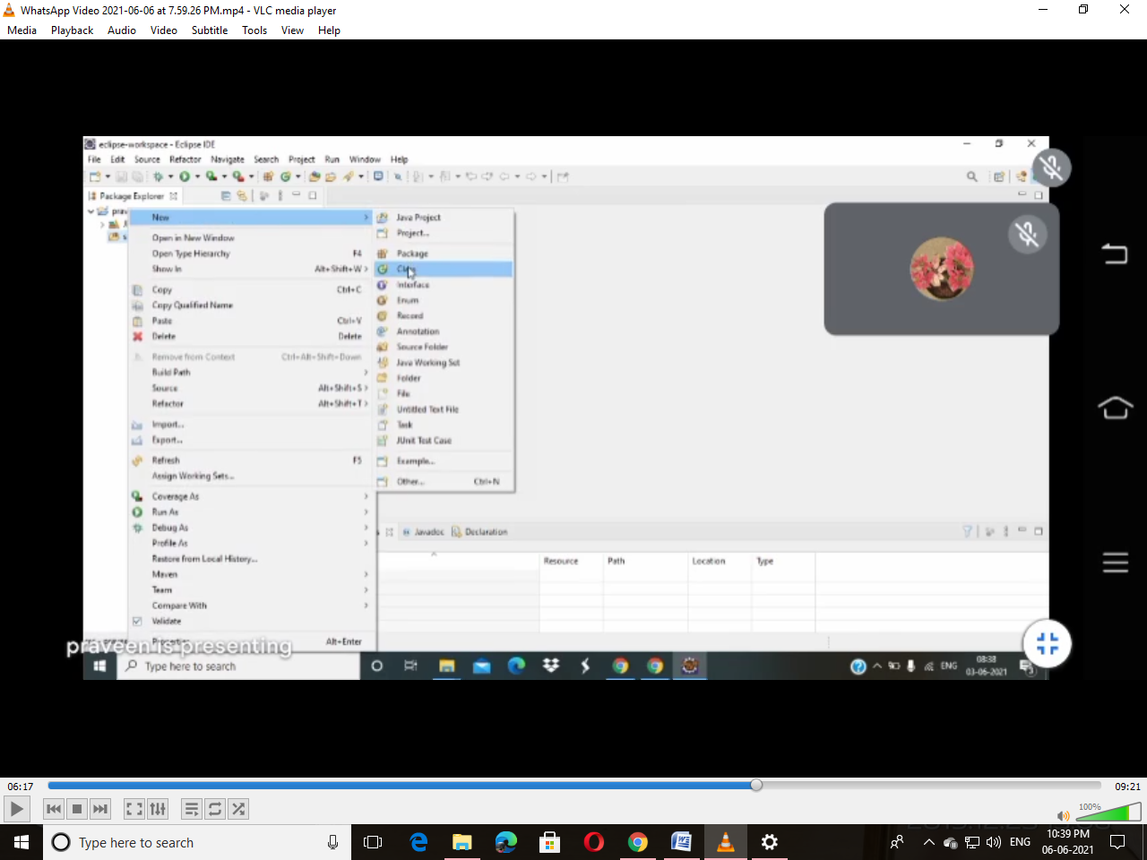

Step21:Give Name for Class and Click Finish Button

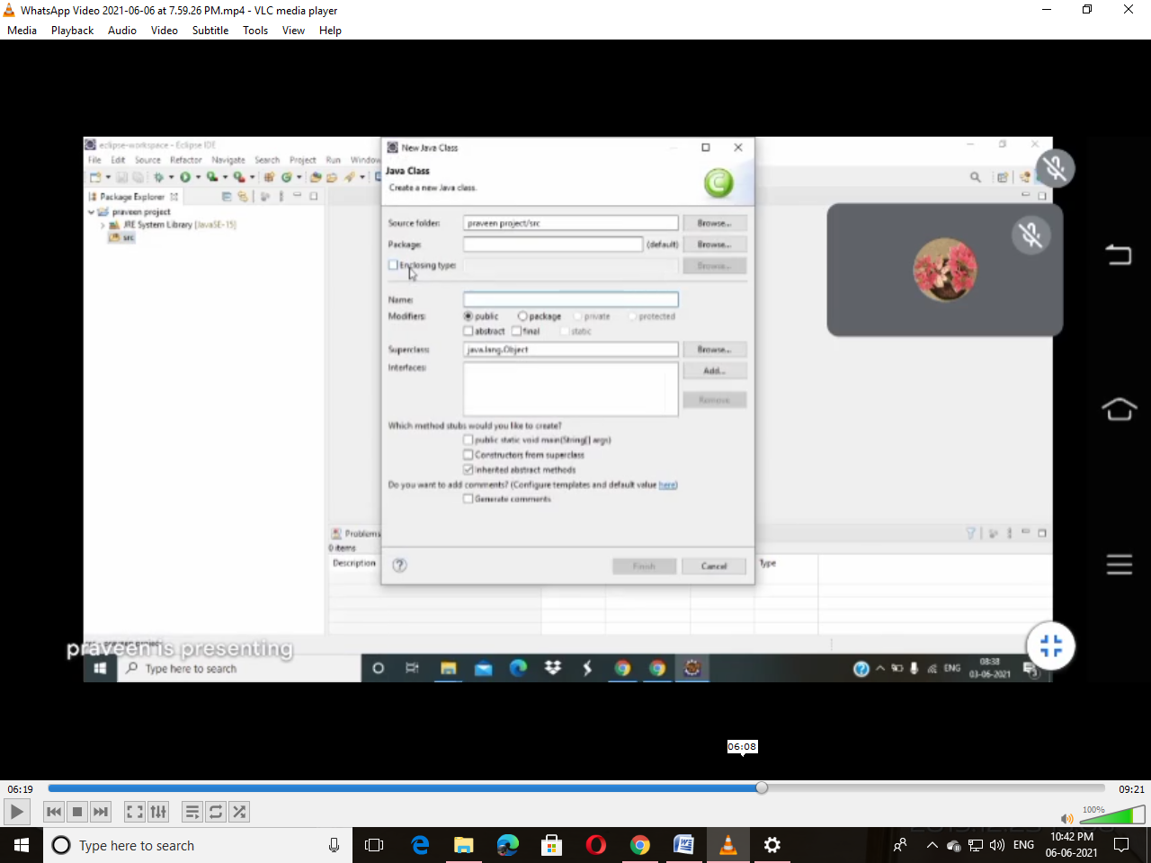

Step22:Write Some Sample Program

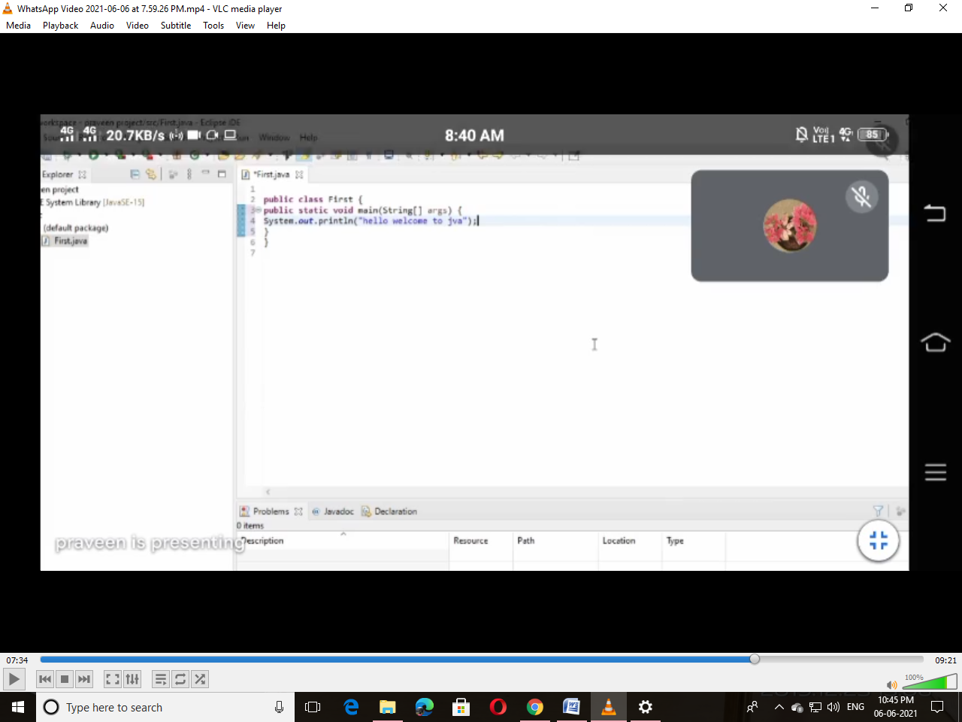

Step23:After Step22 Click Run Button(Left Side of the Window Green Colour Button)

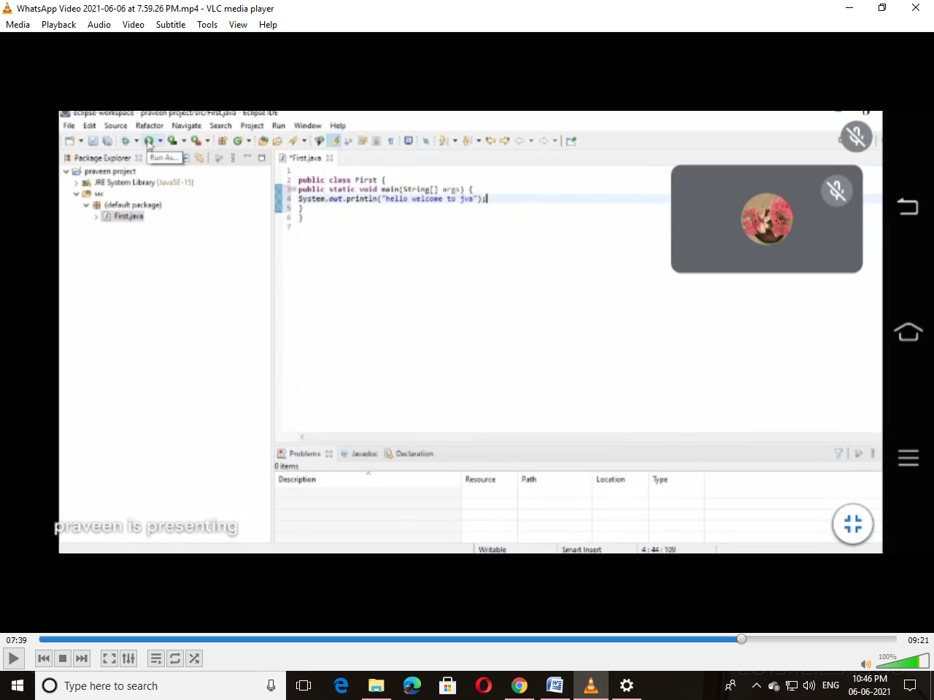

Step24:After Run the Program Click OK Button

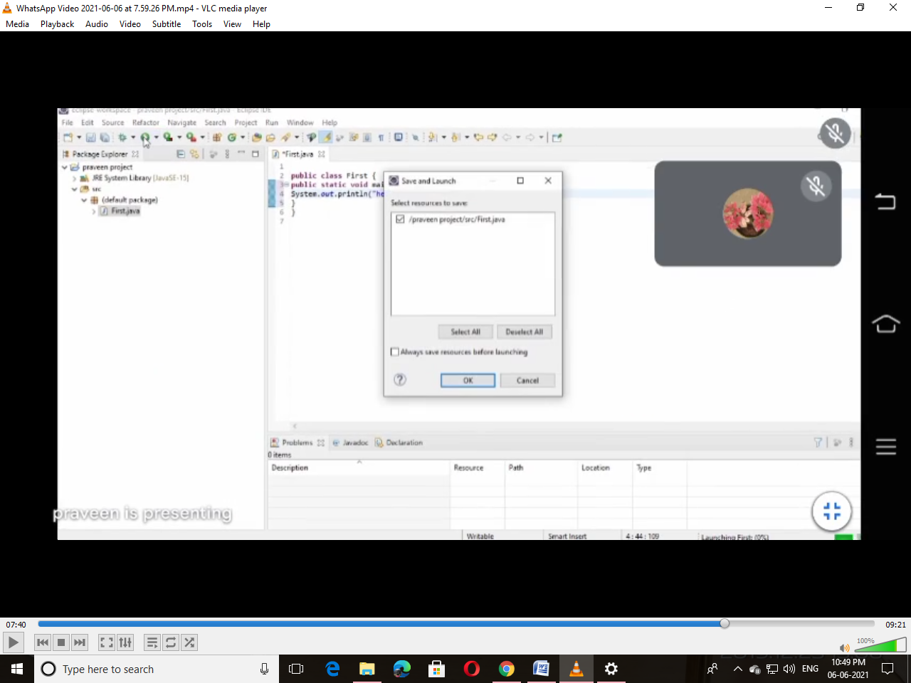

Step25:Result Will Be Displayed Below

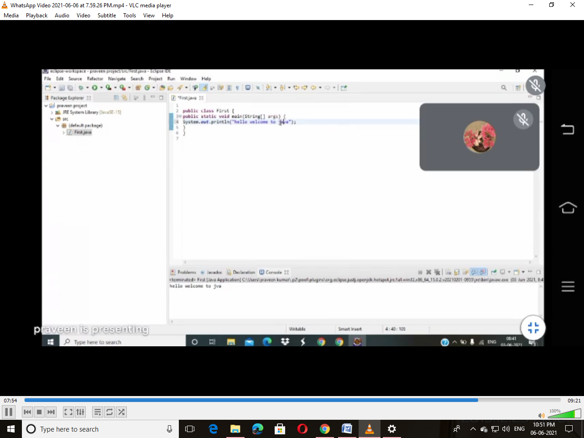

**SQl Commands**

**Create table Student(Rollno number,Name varchar2(20),Adress varchar2(2)**

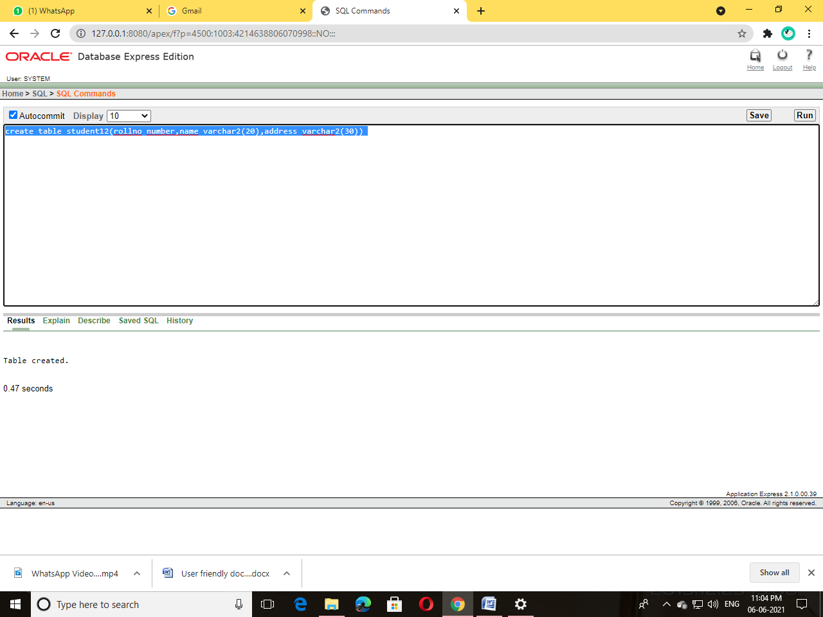

**Insert into Student values(101,’Ravi’,’R T Nagar’)**

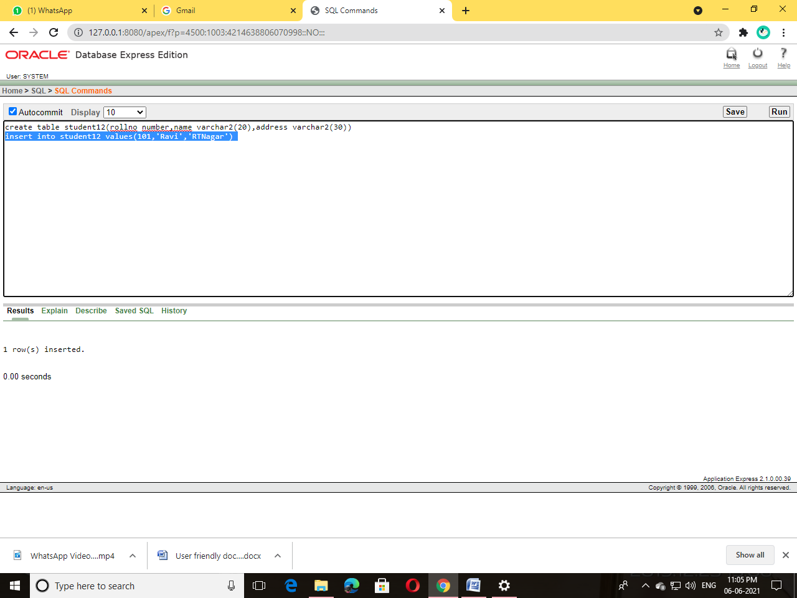

**Select * from Student**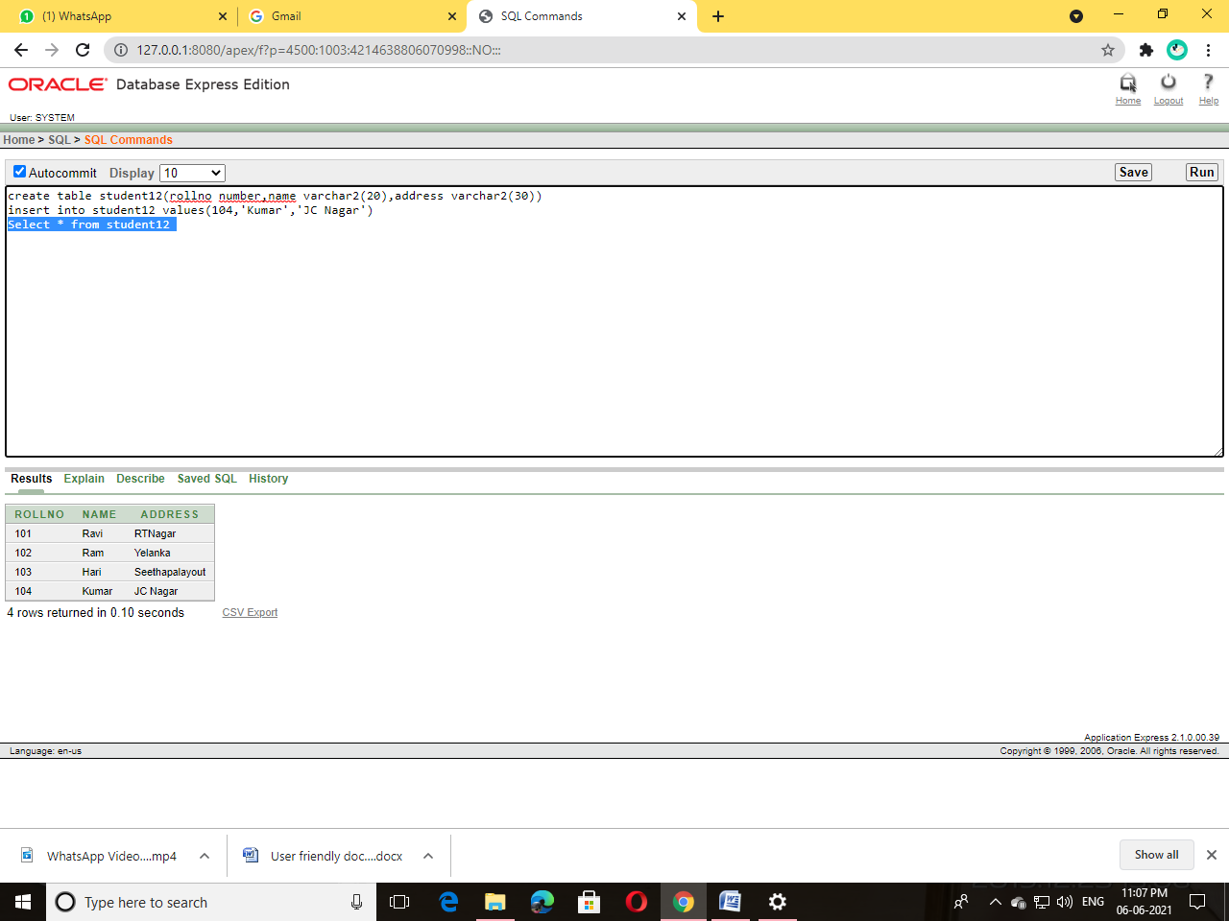

**Update Student set address=’chamundinagar’ where rollno=101**

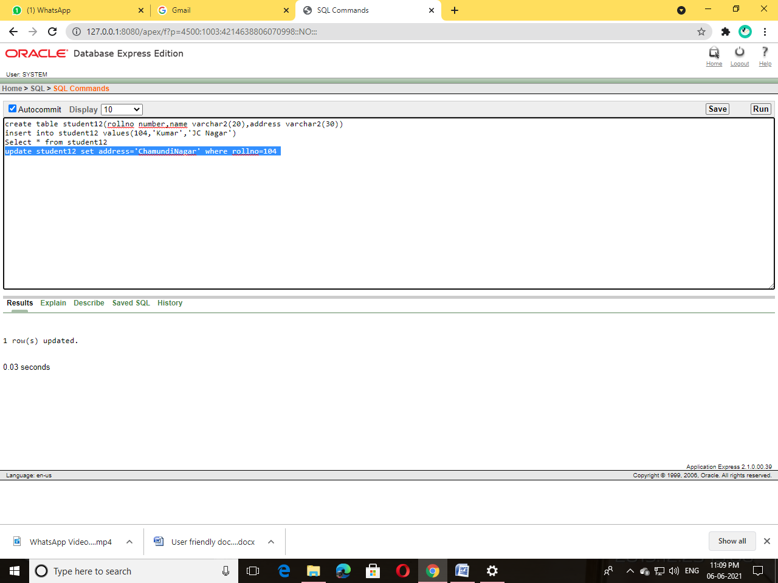

**Alter Command**

Alter table Student add UNIX number

Alter table Student add DBMS number

Alter table Student add VB number

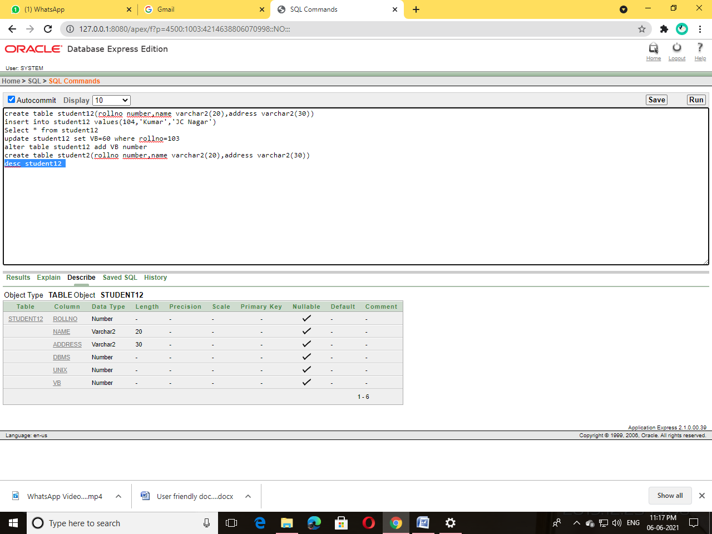

**Adding values to UNIX,DBMS and VB**

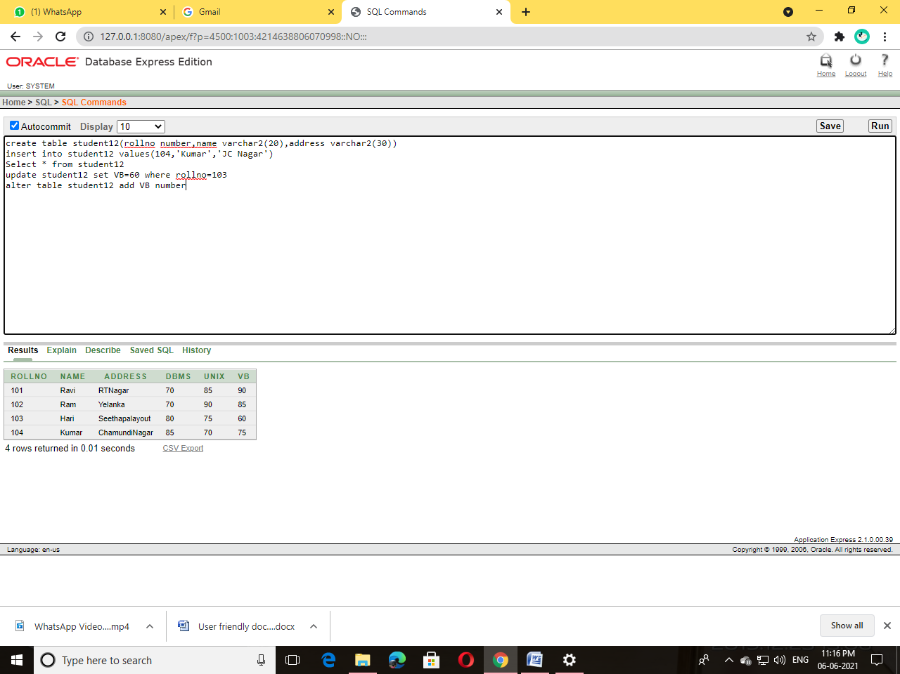

**Truncate Table Student**

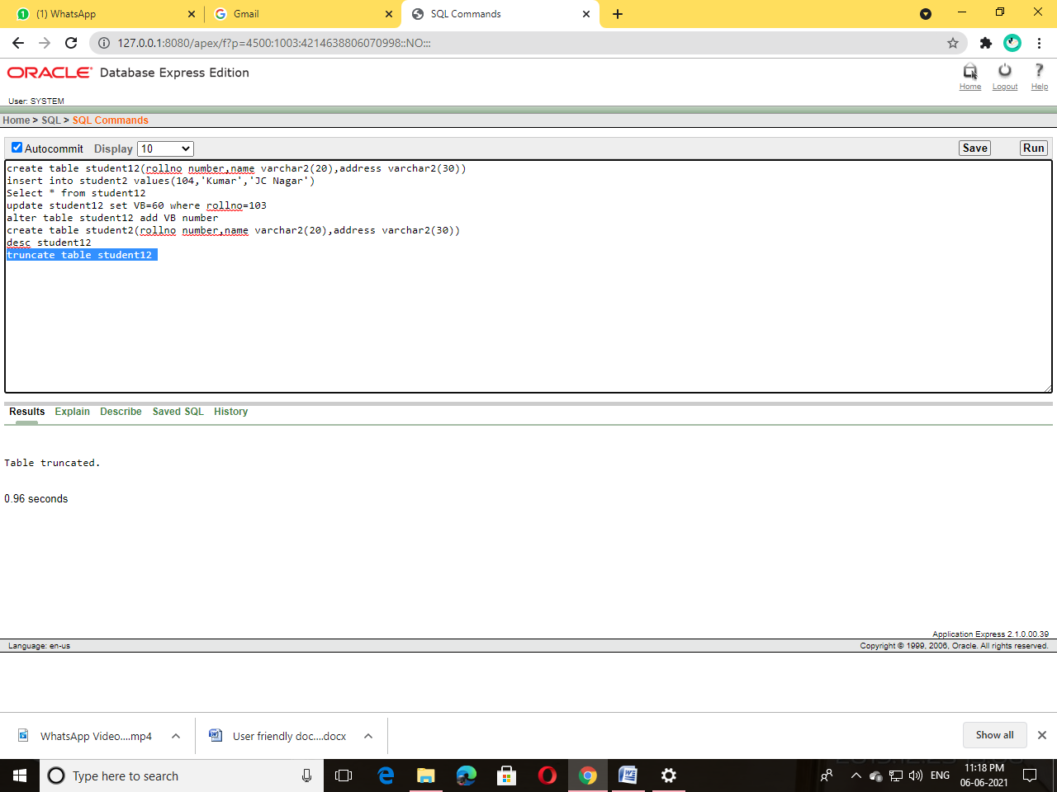

**Drop table Student**

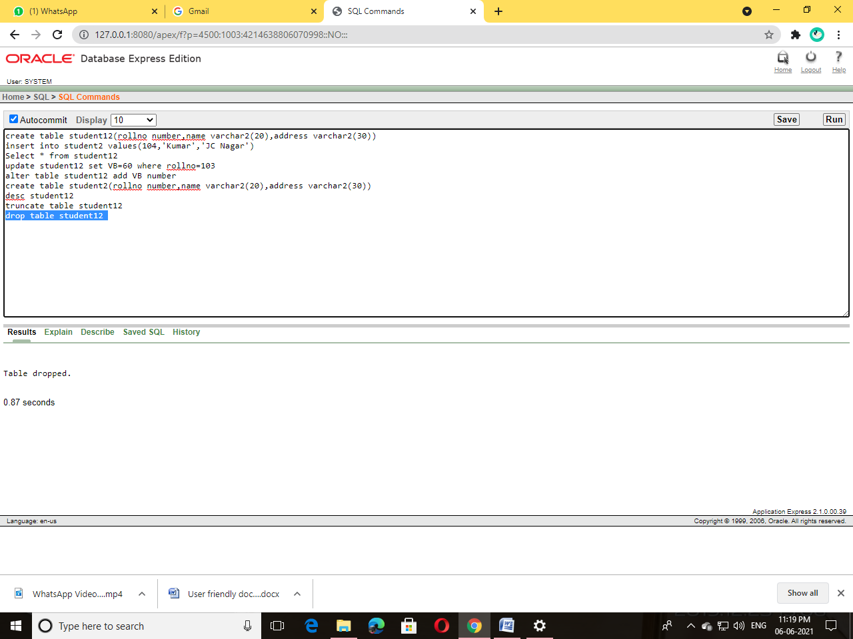

**Alter table Student add total number**

**Update Student set total=DBMS+VB+UNIX where rollno in(101,102,103,104)**

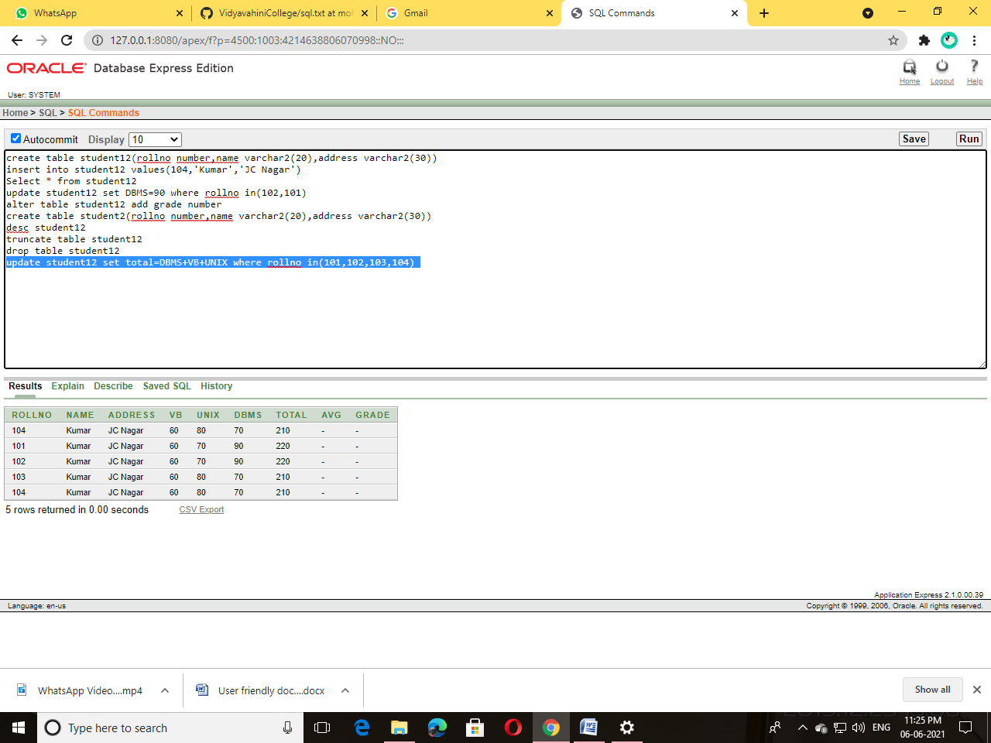

**Alter table Student add avg number**

**Update Student set avg=total/4**

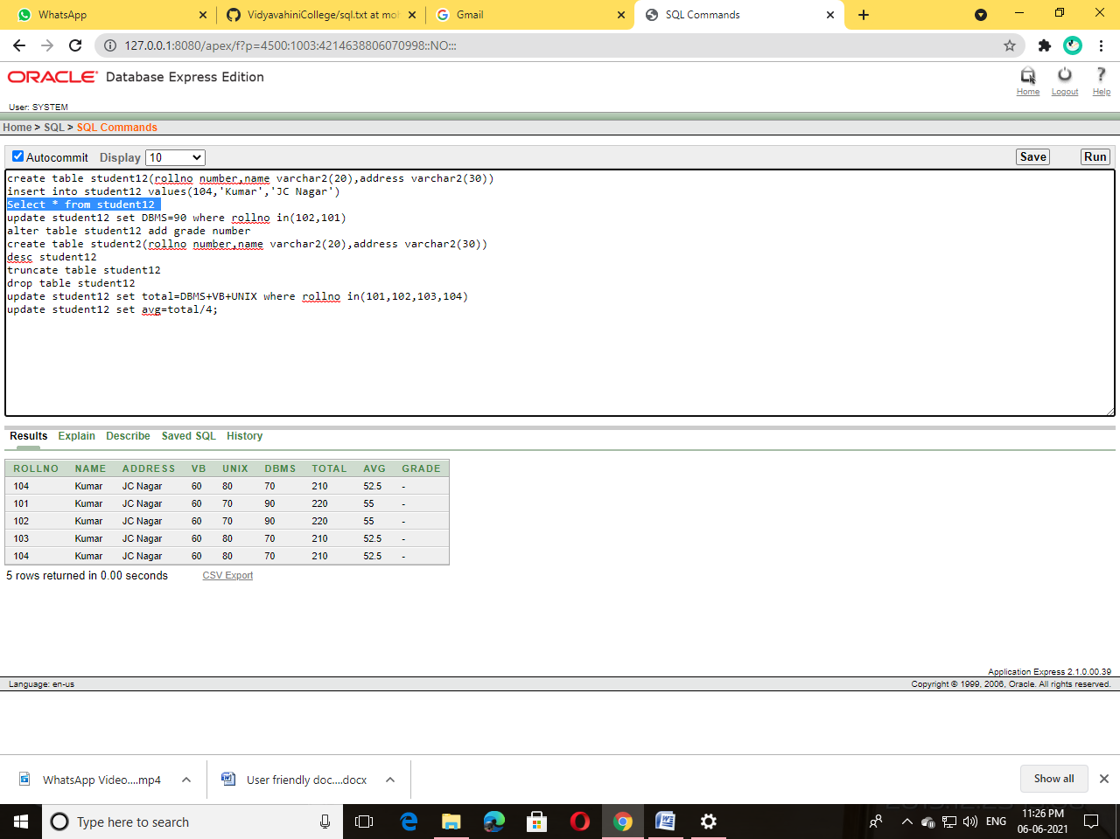

**Alter table Student add grade varchar2(20)**

Update Student set grade=’First Class’ where avg>60

Update Student set grade=’First Class’ where avg<60

